Chemistry | 


Science – States of matter (Year 4)

Outcome: Create an interactive water wheel using my knowledge of the water cycle.

Prior learning
- Identify and compare the suitability of a variety of everyday materials, including wood, metal, plastic, glass, brick, rock, paper and cardboard for particular uses. (Y2 - Uses of everyday materials)
- Find out how the shapes of solid objects made from some materials can be changed by squashing, bending, twisting and stretching. (Y2 - Uses of everyday materials)
- Compare and group together a variety of everyday materials on the basis of whether they are attracted to a magnet, and identify some magnetic materials. (Y3 - Forces and magnets)
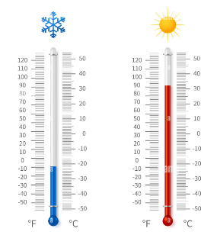
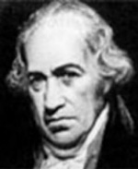
Vocabulary:
States of matter: solids, liquids, gases, particles.
State change: evaporate, condense, melt, freeze, heat, cool, melting point, freezing point, boiling point, water vapour.
Water cycle: precipitation, evaporation, condensation, ground run-off, collection, underground water, bodies of water (sea, river, stream), water droplets, hail.
Other: atmosphere.
Previously introduced vocabulary: temperature, rain, cloud, snow, wind, sun, hot, cold, absorb, carbon dioxide.

Ideas and inspiration:

Daniel Fahrenheit (Physicist who invented
the Fahrenheit temperature scale and the
thermometer) Anders Celsius (Astronomer who invented the degrees Celsius temperature scale)
Enquiries:
Identifying, grouping and classifying  -Based on my own criteria,  classify… | Comparative/ fair testing  - What affects the rate of…

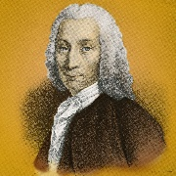




Developing Knowledge and Skills
Scientific Knowledge: |  | Working Towards | Within | Securely Within | Above
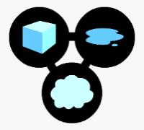 | - Compare and group materials together, according to whether they are solids, liquids or gases.
 | - Observe that some materials change state when they are heated or cooled, and measure or research the temperature at which this happens in degrees Celsius (°C).
 | - Identify the part played by evaporation and condensation in the water cycle and associate the rate of evaporation with temperature.
Working Scientifically (Skills): Plan:  : |  | Working Towards | Within | Securely Within | Above
 | - Ask relevant questions and using different types of scientific enquiries to answer them.
 | - Make systematic and careful observations and, where appropriate, take accurate measurements using standard units, using a range of equipment, including thermometers and data loggers.
Working Scientifically (Skills): Do: |  | Working Towards | Within | Securely Within | Above
 | - Set up simple practical enquiries, comparative and fair tests.
Working Scientifically (Skills): Record: |  | Working Towards | Within | Securely Within | Above
   | - Gather, record, classify and present data in a variety of ways to help in answering questions.
 | - Record findings using simple scientific language, drawings, labelled diagrams, keys, bar charts, and tables .
Working Scientifically (Skills): Review: |  | Working Towards | Within | Securely Within | Above
     | - Identify differences, similarities or changes related to simple scientific ideas and processes.
How can your learning help you with every day activities such as cooking dinner? _______________________________
___________________________________________________________________________________________________
Next year in Year 5, you will learn more about the properties of materials. What else would you like to know? _______
___________________________________________________________________________________________________
Highlights: _________________________________________________________________________________________
___________________________________________________________________________________________________

