Biology  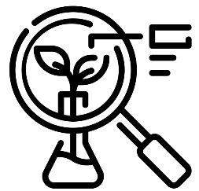 | Chemistry  


Science – Ourselves – Humans and Materials (EYFS)

Outcome: Draw and label a self portrait

The natural world - ELG
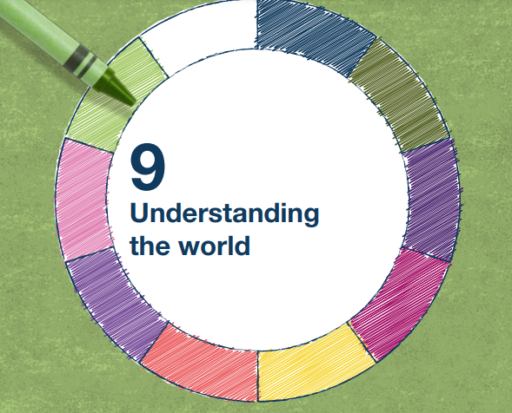 | - Explore the natural world around them, making observations and drawing pictures of animals and plants
 | - Know some similarities and differences between the natural world around them and contrasting environments, drawing on their experiences and what has been read in class
 | - Understand some important processes and changes in the natural world around them, including the seasons and changing states of matter.

Vocabulary:
body parts - head, arms, leg, hand, foot, thigh, elbow, calf, earlobe, etc.
internal body parts – heart, lungs, brain, stomach, muscles, etc.
senses – smell, taste, see, hear, listen, touch, feel sounds - loud, quiet, high pitch, low pitch, ear
stages - baby, toddler, child, teenager, adult, grow,
properties of materials - soft, hard, rough, smooth, prickly, spiky, fluffy, smelly, salty, etc.
height, tall, taller, short, shorter

Ideas and inspiration:
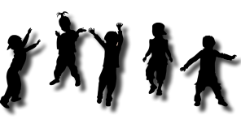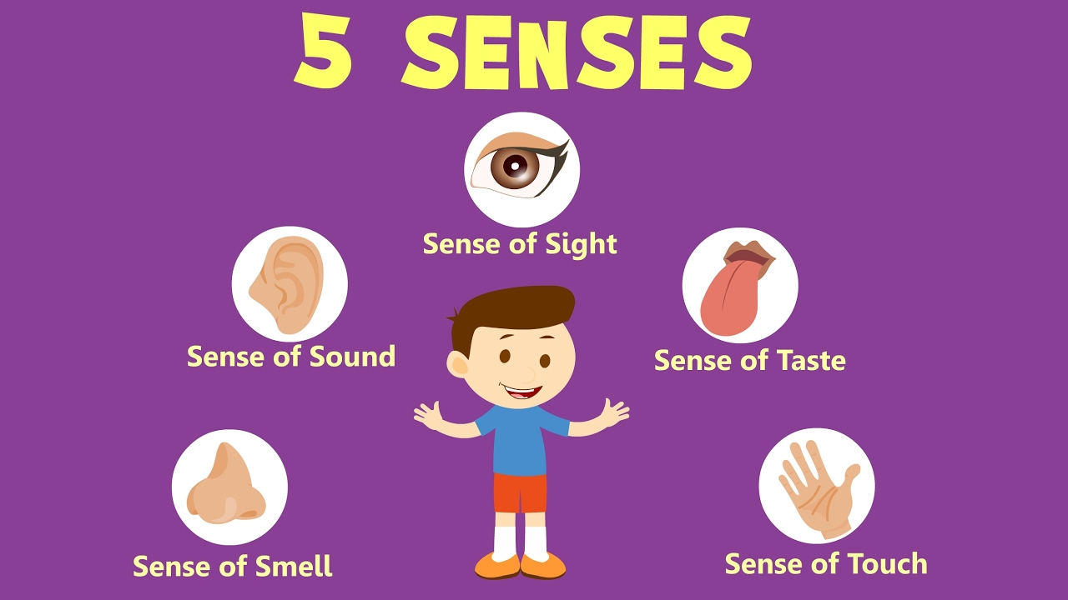

Scientific Knowledge: Humans |  | Emerging | Expected
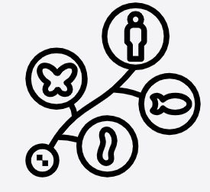 | - Name and describe people who are familiar to them.
 | - Continue developing positive attitudes about the differences between people.
 | - Name body parts that we are similar (have same body parts) and different (different heights).
 | - Humans change as they group up.
Scientific Knowledge: Materials |  | Emerging | Expected
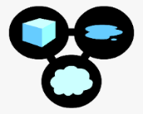 | - Use all their senses in hands-on exploration of materials. (Nursery)
 | - Different objects can make different sounds.
Working Scientifically: |  | Emerging | Expected
   | - Observe and describe faces.
 | - Notice and describe different smells and tastes
 | - Notice and describe how objects feel.
 | - Notice and describe different sounds.
 | - Notice similarities and differences.

