Physics  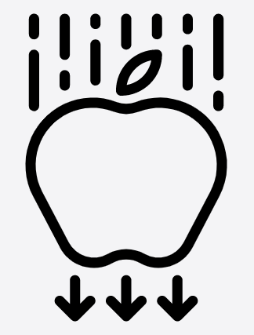 | Biology  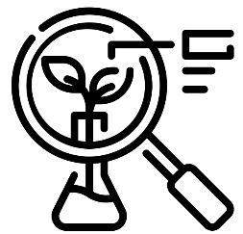


Science – Autumn Trees – Seasonal changes, Living things, Animals (EYFS)
Outcome: Observe a chosen tree throughout the year and recognise changes.

The natural world - ELG
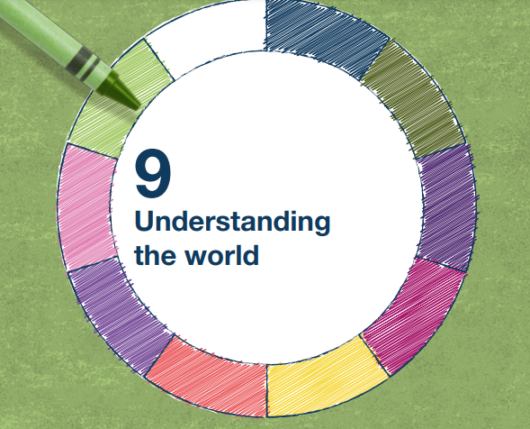 | - Explore the natural world around them, making observations and drawing pictures of animals and plants
 | - Know some similarities and differences between the natural world around them and contrasting environments, drawing on their experiences and what has been read in class
 | - Understand some important processes and changes in the natural world around them, including the seasons and changing states of matter.

Vocabulary:
Trees - oak, conifer, beech, hawthorn, sycamore,
Natural objects - leaf/leaves, bark, trunk, twig, stick, seeds, nuts, acorn, pine cone, berries, moss, bracken, stones, soil, mud
Senses - touch, smell, sight
Seasons – autumn, winter, spring, summer, changes
Ideas and inspiration:
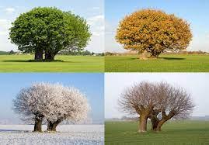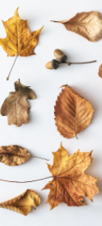

Scientific Knowledge: Seasonal changes |  | Emerging | Expected
 | - Explore the natural world around them.
 | - Describe what they see, hear and feel whilst outside.
 | - Understand the effect of changing seasons on the natural world around them.
Scientific Knowledge: Living things (including animals) |  | Emerging | Expected
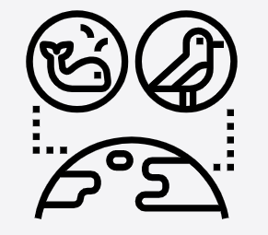 | - Begin to understand the need to respect and care for the natural environment and all living things. (Nursery)
 | - Understand the key features of the life cycle of a plant and an animal. (Nursery)
Working Scientifically: |  | Emerging | Expected
   | - Use senses to find out about the natural world around them.
 | - Observe closely and overtime.
 | - To sort objects into groups.

