Biology  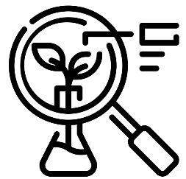 | Chemistry  


Science – Supertato – Plants, Animals and Materials (EYFS)
Outcome: Observe the lifecycle of a plant through planting potatoes.

The natural world - ELG
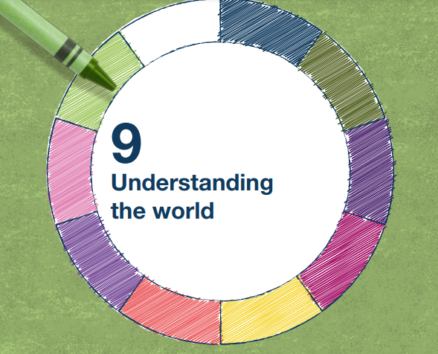 | - Explore the natural world around them, making observations and drawing pictures of animals and plants
 | - Know some similarities and differences between the natural world around them and contrasting environments, drawing on their experiences and what has been read in class
 | - Understand some important processes and changes in the natural world around them, including the seasons and changing states of matter.

Vocabulary:
names of vegetables - potato, cabbage, carrot, celery, etc. texture, mash, cut properties of materials - rough, smooth, soft, hard, sticky, slippery, spiky ice, water, freeze, frozen, melt, salt plant, stem, leaf, root, flower, tuber, seed, shoot, grow, camouflage

Ideas and inspiration:

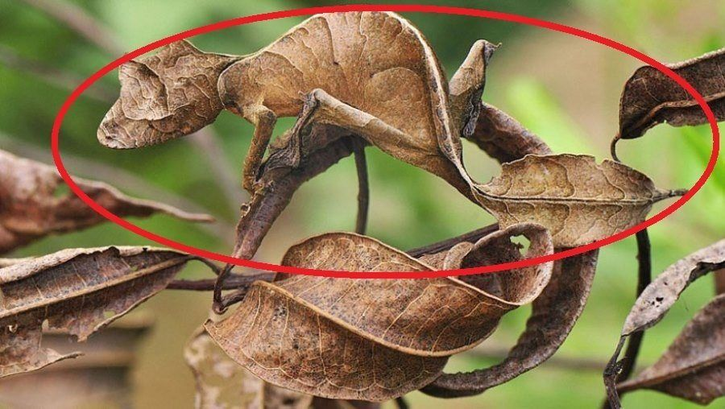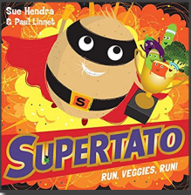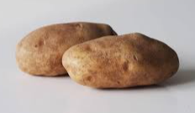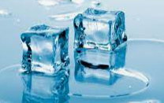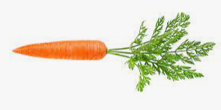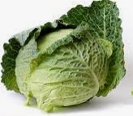

Scientific Knowledge: Plants and animals |  | Emerging | Expected
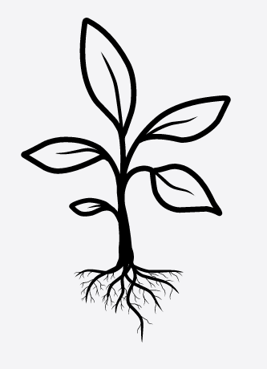   | - Plant seeds and care for growing plants. (Nursery)
 | - Understand the key features of the life cycle of a plant and an animal. (Nursery)
 | - Know that objects and animals are hard to find if they are camouflaged.
 | - Know what plants need to grow.
 | - Name a variety of vegetables.
Scientific Knowledge: Materials |  | Emerging | Expected
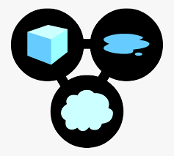 | - Talk about the differences between materials and changes they notice. (Nursery)
 | - Describe some materials can change texture.
 | - To know that ice melts when it gets warmer (Rescue frozen vegetables!)
Working Scientifically: |  | Emerging | Expected
   | - Ask and raise questions.
 | - Make observations of animals and plants and explain why some things occur and talk about changes.
 | - Notice and describe textures of vegetables.

