

Science – Plants (EYFS)

Outcome: Observe the life cycle of a plant through growing cress.

The natural world - ELG
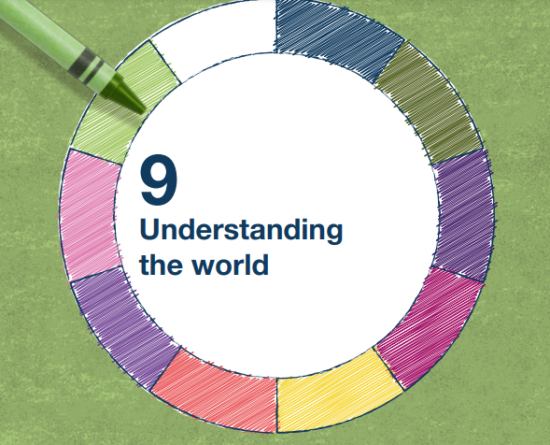 | - Explore the natural world around them, making observations and drawing pictures of animals and plants
 | - Know some similarities and differences between the natural world around them and contrasting environments, drawing on their experiences and what has been read in class
 | - Understand some important processes and changes in the natural world around them, including the seasons and changing states of matter.

Ideas and inspiration:
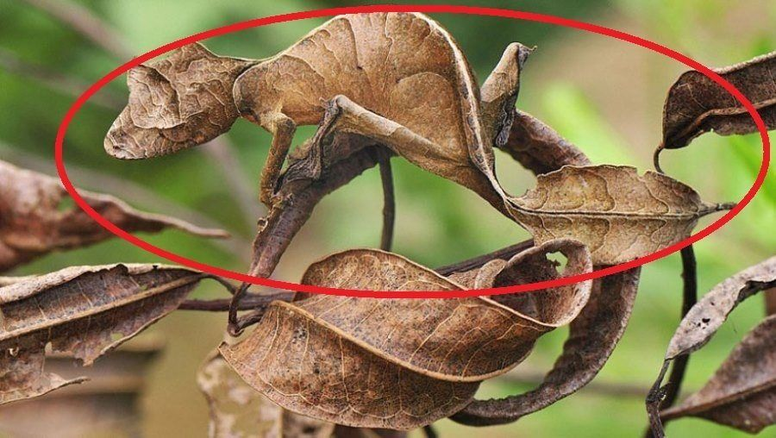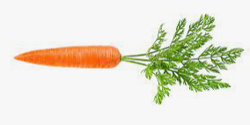
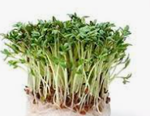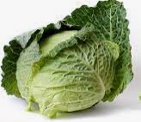

Vocabulary:
names of vegetables and plants- potato, cabbage, carrot, celery, cress, carnations, texture, mash, cut, pointy, rough, smooth, soft, hard, sticky, water, plant, stem, leaf, root, flower, tuber, seed, shoot, grow, healthy,

Scientific Knowledge: |  | Emerging | Expected
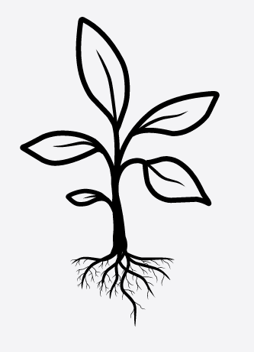 | - To know what plants need to grow
 | - To name a variety of vegetables
 | - To describe some materials change texture - to describe textures of vegetables
Working Scientifically: |  | Emerging | Expected
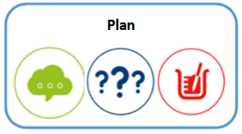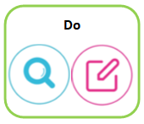 | - Talk about features of their immediate environment and how environments might vary from one another.
 | - Ask and raise questions
 | - Make observations of animals and plants and explain why some things occur and talk about changes.

