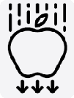


Outcome: investigate how different forces work on objects.
Physics

Prior Knowledge and Skills
Compare how things move on different surfaces. (Y3 - Forces and magnets)
Notice that some forces need contact between two objects, but magnetic forces can act at a distance. (Y3 - Forces and magnets)
Observe how magnets attract or repel each other and attract some materials and not others. (Y3 - Forces and magnets)
Compare and group together a variety of everyday materials on the basis of whether they are attracted to a magnet, and identify some magnetic materials. (Y3 - Forces and magnets)
Describe magnets as having two poles. (Y3 - Forces and magnets)
Predict whether two magnets will attract or repel each other, depending on which poles are facing. (Y3 - Forces and magnets)
Describe the movement of the Earth, and other planets, relative to the Sun in the solar system. (Y5 – Earth and space)

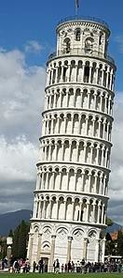  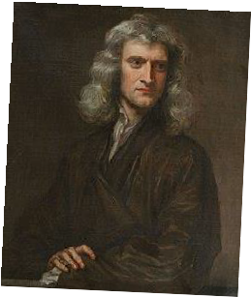  Ideas and inspiration  Archimedes (Mathematician who developed theories about how levers and pulleys can lift and move heavy objects)  Galileo Galilei (Astronomer, Mathematician & Physicist who was the first person to use the scientific method to test theories about gravity  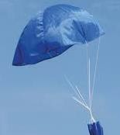  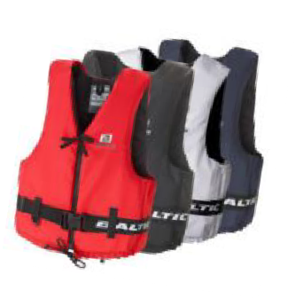  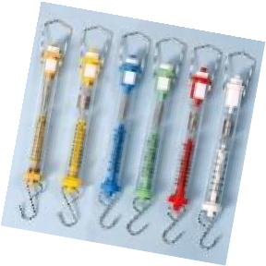  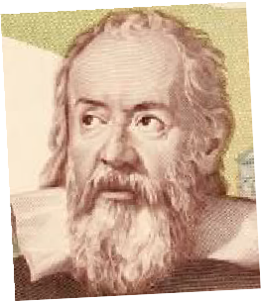  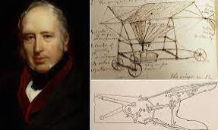  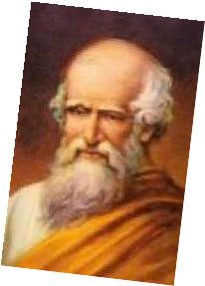  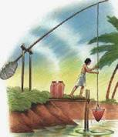  and the Solar System)  Isaac Newton (Mathematician &  Physicist who developed theories about gravity)  George Cayley (Aeronautical Engineer who  designed the first successful glider to carry a human being)  Egyptian shaduf (a hand-operated machine used to transport water from a lower level to a higher one.) |  | Vocabulary:  types of forces:  air resistance, water resistance, buoyancy, upthrust, Earth’s gravitational pull, gravity, opposing forces, driving force.  mechanisms:  levers, pulleys, gears/cogs.  measurements:  weight, mass, kilograms (kg), Newtons (N), scales, speed, fast, slow.  other: streamlined, Earth.  previously introduced vocabulary:  air, heat, moon

Developing Knowledge and Skills
Scientific Knowledge: |  | Working Towards | Within | Securely Within | Above
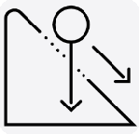 | Explain that unsupported objects fall towards the Earth because of the force of gravity acting between the Earth and the falling  object.
 | Identify the effects of air resistance, water resistance and friction, that act between moving surfaces.
 | Recognise that some mechanisms, including levers, pulleys and gears, allow a smaller force to have a greater effect.
Working Scientifically (Skills): Plan:  : |  | Working  Towards | Within | Securely Within | Above
 | Plan different types of scientific enquiries to answer questions, including recognise and controlling variables where necessary.
Working Scientifically (Skills): Do: |  | Working  Towards | Within | Securely Within | Above
 | Take measurements, using a range of scientific equipment, with increasing accuracy and precision, take repeat readings when  appropriate.

Working Scientifically (Skills): Record: |  | Working Towards | Within | Securely Within | Above
 |   Record data and results of increasing complexity using scientific diagrams and labels, classification keys, tables, scatter graphs,  bar and line graphs.
Working Scientifically (Skills): Review: |  | Working Towards | Within | Securely Within | Above
 | Report and present findings from enquiries, including conclusions, causal relationships and explanations of and degree of trust in results, in oral and written forms such as displays and  other presentations
Use test results to make predictions to set up further
comparative and fair tests.
Working Scientifically (Enquiries): Comparative/ fair testing: |  | Working Towards | Within | Securely Within | Above
 | Carry out a range of tests, potentially comparing: friction  water resistance e.g. boats in a gutter of water, plasticine in a cylinder of liquid  air resistance e.g. spinners, parachutes, sailing boats, straw  rockets
Highlights:

