Physics | 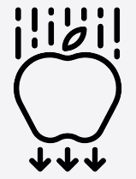


Science – Earth and Space (Year 5)
Outcome: Create a model to explain movement of Earth around the sun.

Prior Knowledge and Skills
- Explore the natural world around them. (EYFS)
- Describe what they see, hear and feel whilst outside. (EYFS)
- Observe changes across the four seasons. (Y1 – Seasonal changes)
- Observe and describe the weather associated with the seasons and how day length varies. (Y1 – Seasonal changes)

Vocabulary:
- Solar system
- Mercury, Venus, Mars, Jupiter, Saturn, Uranus, Neptune
- Pluto (dwarf planet)
- celestial body
- sphere / spherical
- rotate / rotation
- orbit
- revolve
- geocentric model
- heliocentric model
- secondary source
- shadow clocks/ sundials/ astronomical clocks

Ideas and inspiration:

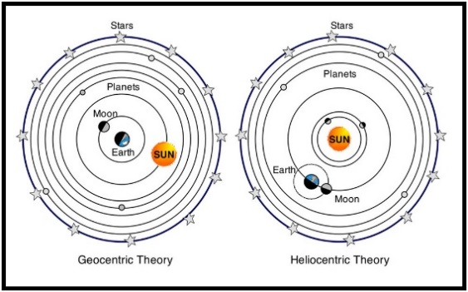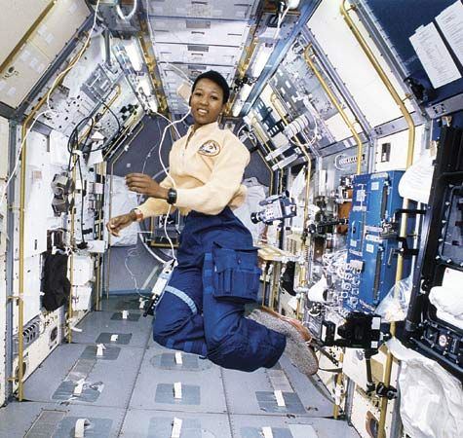

Margaret Hamilton (Computer Scientist who was responsible for the software that allowed astronauts Neil Armstrong and Buzz Aldrin to land on the Moon).
Mae Jemison (Astronaut and first Black woman in space).
Stephen Hawking (Physicist & Cosmologist who developed the theory that the Big Bang may have been caused by a black hole in reverse)

Ink sketching techniques Completed self-portrait sketch example

Developing Knowledge and Skills
Scientific Knowledge: |  | Working Towards | Within | Securely Within | Above
 | - Describe the movement of the Earth, and other planets, relative to the Sun in the solar system.
 | - Describe the movement of the Moon relative to the Earth.
 | - Describe the Sun, Earth and Moon as approximately spherical bodies.
 | - Use the idea of the Earth’s rotation to explain day and night and the apparent movement of the sun across the sky.
Working Scientifically (Skills): Plan: |  | Working Towards | Within | Securely Within | Above
 | - Plan different types of scientific enquiries to answer questions, including recognising and controlling variables where necessary.
 | - Select and plan the most appropriate type of scientific enquiry to use to answer scientific questions.
Working Scientifically (Skills): Review: |  | Working Towards | Within | Securely Within | Above
 | - Recognise which secondary sources will be most useful to research their ideas and begin to separate opinion from fact.
 | - Identify scientific evidence that has been used to support or refute ideas or arguments.
 | - Report and present findings from enquiries, including conclusions, causal relationships and explanations of and degree of trust in results, in oral and written forms such as displays and other presentations.
 | - Use relevant scientific language and illustrations to discuss, communicate and justify their scientific ideas
Working Scientifically (Enquiries): Observing over time: |  | Working Towards | Within | Securely Within | Above
 | - Measure shadows throughout the day.
Working Scientifically (Enquiries): Researching |  | Working Towards | Within | Securely Within | Above
 | - Generate questions to research about the Earth and Space.
Highlights: _________________________________________________________________________________________
___________________________________________________________________________________________________

