Physics | 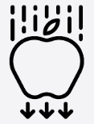


Science – Electricity (Year 4)
Outcome: To create a circuit with bulbs and switches.

Prior Knowledge and Skills
- Recognise that they need light in order to see things and that dark is the absence of light (Year 3 – Light)
- Ask simple questions and recognising that they can be answered in different ways (KS1 – Working Scientifically)
- Gather and record data to help in answering questions. (KS1 – Working Scientifically)

Ideas and inspiration:  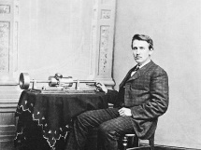  Thomas Edison (Inventor of the lightbulb and power grid)  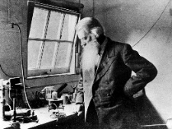  Joseph Swan (Physicist & Chemist who developed a primitive electric light 20 years before Thomas Edison)  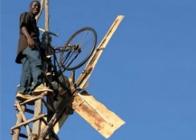  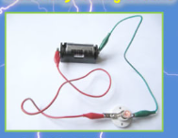  William Kamkwamba (Inventor who used wind turbines to bring electricity to his village in Malawi)    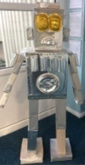  Zubera Iqbal (Chemist who explores sustainable ways to recycle electric vehicle batteries)  DT Link: Iron Man: 3D Iron Man (Structures and Electrical Systems) |  | Vocabulary:  electricity:  mains-powered, battery-powered, mains electricity, plug, appliances, devices.  circuits:  circuit, simple series circuit, complete circuit, incomplete circuit.  circuit parts:  bulb, cell, wire, buzzer, switch, motor, battery.  materials:  electrical conductor, electrical insulator.  other:  safety.  previously introduced vocabulary: names of materials.

Developing Knowledge and Skills
Scientific Knowledge: |  | Working Towards | Within | Securely Within | Above
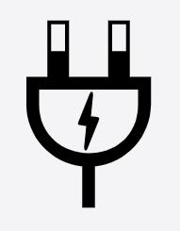 | - Identify common appliances that run on electricity.
 | - Construct a simple series electrical circuit, identifying and naming its basic parts, including cells, wires, bulbs, switches and buzzers.
 | - Identify whether or not a lamp will light in a simple series circuit, based on whether or not the lamp is part of a complete loop with a battery.
 | - Recognise that a switch opens and closes a circuit and associate this with whether or not a lamp lights in a simple series circuit.
 | - Recognise some common conductors and insulators, and associate metals with being good conductors.
Working Scientifically (Skills): Plan:  : |  | Working Towards | Within | Securely Within | Above
 | - Ask relevant questions and using different types of scientific enquiries to answer them.
 | - Set up simple practical enquiries, comparative and fair tests.
Working Scientifically (Skills): Do: |  | Working Towards | Within | Securely Within | Above
 | - Make systematic and careful observations and, where appropriate, take accurate measurements using standard units, using a range of equipment, including thermometers and data loggers.
Working Scientifically (Skills): Record: |  | Working Towards | Within | Securely Within | Above
 | - Record findings using simple scientific language, drawings, labelled diagrams, keys, bar charts, and tables
Working Scientifically (Skills): Review: |  | Working Towards | Within | Securely Within | Above
 | - Report on findings from enquiries, including oral and written explanations, displays or presentations of results and conclusions.
Highlights: _________________________________________________________________________________________
___________________________________________________________________________________________________



