Biology | 


Science – Animals, including humans (Year 1)
Outcome: Label a photo with basic parts and senses.
Prior Knowledge and Skills
- Name and describe people who are familiar to them.
- Continue developing positive attitudes about the differences between people.
- Name body parts that we are similar (have same body parts) and different (different heights).
- Understand that humans change as they group up.

Ideas and inspiration:  Miller Hutchinson (Engineer who invented the first electric hearing aid)    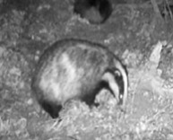  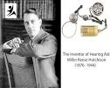  Tanesha Allen (Zoologist who studies badgers) https://pstt.org.uk/application/files/7016/2851/6694/Zoologist_-_Tanesha_Allen.pdf |  | Vocabulary:  senses taste sight smell touch hear carnivore herbivore omnivore diet fish amphibians reptiles birds mammals pet head arm stomach leg neck elbow knee eyes ears mouth nose

Developing Knowledge and Skills
Scientific Knowledge: |  | Working Towards | Within | Securely Within | Above
 | - Identify and name a variety of common animals including fish, amphibians, reptiles, birds and mammals.
 | - Identify and name a variety of common animals that are carnivores, herbivores and omnivores.
 | - Describe and compare the structure of a variety of common animals (fish, amphibians, reptiles, birds and mammals, including pets).
 | - Identify, name, draw and label the basic parts of the human body and say which part of the body is associated with each sense.
Working Scientifically (Skills): Plan: |  | Working Towards | Within | Securely Within | Above
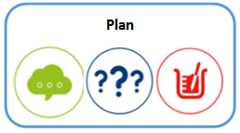 | - Ask simple questions and recognise that they can be answered in different ways.
Working Scientifically (Skills): Do: |  | Working Towards | Within | Securely Within | Above
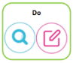 | - Observe closely, using simple equipment.
 | - Identify and classify.
Working Scientifically (Enquiries): Identifying, grouping, and classifying: |  | Working Towards | Within | Securely Within | Above
 | - Classify animals they have seen/have first-hand experience of, choosing their own criteria to do so.
Working Scientifically (Enquiries) Pattern seeking |  | Working Towards | Within | Securely Within | Above
 | - Generate questions for investigations, such as: Do people with longer arms have longer legs? Do all animals with … have … ?
Working Scientifically (Enquiries): Comparative/ fair testing: |  | Working Towards | Within | Securely Within | Above
 | - Carry out taste tests
Working Scientifically (Enquiries): Researching |  | Working Towards | Within | Securely Within | Above
 | - Use secondary sources to name animals seen in the local environment.
Highlights: _________________________________________________________________________________________
___________________________________________________________________________________________________

