Physics | 


Science – Seasonal Changes (Year 1)
Outcome: recognise changes across the seasons.
Prior learning
- Explore the natural world around them. (EYFS – Autumn Trees)
- Describe what they see, hear and feel whilst outside. (EYFS – Autumn Trees)
- Understand the effect of changing seasons on the natural world around them. (EYFS – Autumn Trees)

Ideas and inspiration:  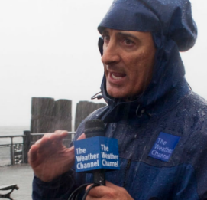  Jim Cantore (Meteorologist and storm tracker) 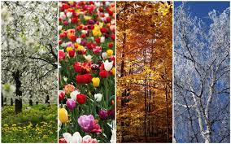 |  | Vocabulary:  seasons: spring, summer, autumn, winter, seasonal change.  weather: e.g. sun, rain, snow, sleet, frost, ice, fog, cloud, hot/warm, cold, storm, wind, thunder, weather forecast.  measuring weather: temperature, rainfall, wind direction, thermometer, rain gauge.  day length: night, day, daylight, sunrise, sunset, hours
  Enquiries:
    Observing over time  -Take weather measurements and make observations over time.  -Record/Photograph what children are wearing (jumper, coat, hats, scarves, etc.)  -Make observations of daylight hours. |   Pattern seeking  - At the end of the year, look for patterns in evidence e.g. Does it rain more in spring? Do we have more sunny days in the summer? Which was the coldest month?

Developing Knowledge and Skills
Scientific Knowledge: |  | Working Towards | Within | Securely Within | Above
 | - Observe changes across the four seasons.
 | - Observe and describe weather associated with the seasons and how day length varies.
Working Scientifically (Skills): Do: |  | Working Towards | Within | Securely Within | Above
 | - Observe closely, using simple equipment.
Working Scientifically (Skills): Record: |  | Working Towards | Within | Securely Within | Above
 | - Gather and record data to help in answering questions.
Working Scientifically (Skills): Review: |  | Working Towards | Within | Securely Within | Above
 | - Use observations and ideas to suggest answers to questions.
 | - Communicate findings in a range of ways and begin to use simple scientific language.
Highlights: _________________________________________________________________________________________
___________________________________________________________________________________________________

