Biology | 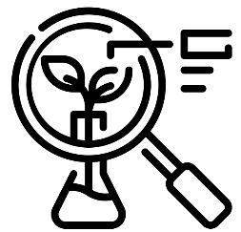


Science – Evolution and inheritance (Year 6)
Outcome: Present knowledge and understanding of evolution and inheritance.
Prior Knowledge and Skills
- Identify that most living things live in habitats to which they are suited and describe how different habitats provide for the basic needs of different kinds of animals and plants, and how they depend on each other. (Y2 - Living things and their habitats)
- Notice that animals, including humans, have offspring which grow into adults. (Y2 - Animals, including humans)
- Explore the part that flowers play in the life cycle of flowering plants, including pollination, seed formation and seed dispersal. (Y3 - Plants)
- Describe in simple terms how fossils are formed when things that have lived are trapped within rock. (Y3 - Rocks)
- Recognise that environments can change and that this can sometimes pose dangers to living things. (Y4 - Living things and their habitats)
- Describe the life process of reproduction in some plants and animals. (Living things and their habitats - Y5)

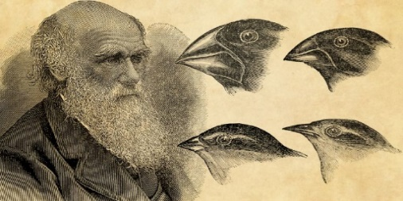  Ideas and inspiration:  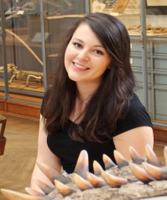  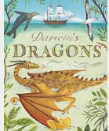  Charles Darwin (Natural Historian who developed the theory of evolution by natural selection)  Emma Dunne (Palaeobiologist who investigates how ancient climate change affected the evolution of different species)  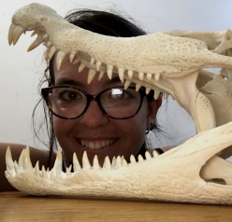  Telma Laurentino (Evolutionary Biologist who measures differences in the colour of lizards that live in white desert sands to find differences in their genes which might have allowed them to survive in such an extreme environment) |  | Vocabulary:  offspring, sexual reproduction, vary, characteristics, suited, adapted, environment, inherited, species, fossils

Developing Knowledge and Skills
Scientific Knowledge: |  | Working Towards | Within | Securely Within | Above
 | - Recognise that living things have changed over time and that fossils provide information about living things that inhabited the Earth millions of years ago.
 | - Recognise that living things produce offspring of the same kind, but normally offspring vary and are not identical to their parents.
 | - Identify how animals and plants are adapted to suit their environment in different ways and that adaptation may lead to evolution.
Working Scientifically (Skills): Record: |  | Working Towards | Within | Securely Within | Above
 | - Record data and results of increasing complexity using scientific diagrams and labels, classification keys, tables, scatter graphs, bar and line graphs.
 | - Use and develop keys and other information records to identify, classify and describe living things and materials, identify patterns that might be found in the natural environment.
Working Scientifically (Skills): Review: |  | Working Towards | Within | Securely Within | Above
 | - Recognise which secondary sources will be most useful to research their ideas.
 | - Identify scientific evidence that has been used to support or refute ideas or arguments.
 | - Report and present findings from enquiries, including conclusions, causal relationships and explanations of and degree of trust in results, in oral and written forms such as displays and other presentations.
Working Scientifically (Enquiries) Pattern seeking |  | Working Towards | Within | Securely Within | Above
 | - Use different pieces of equipment, (e.g. chopsticks, toothpicks, cutlery) to look for patterns linking the suitability of bird beaks for the available food (e.g. rice, grapes, raisins).
Working Scientifically (Enquiries): Researching |  | Working Towards | Within | Securely Within | Above
 | - Research different types of species and their characteristics making them suitable for different habitats (e.g. penguins).
Highlights: _________________________________________________________________________________________
___________________________________________________________________________________________________

