
WªoŒ„[i[n]ü ¡]c[¬e[n[t[i»i]c]a[l[l[þ ªa[t

Enquiry Approaches
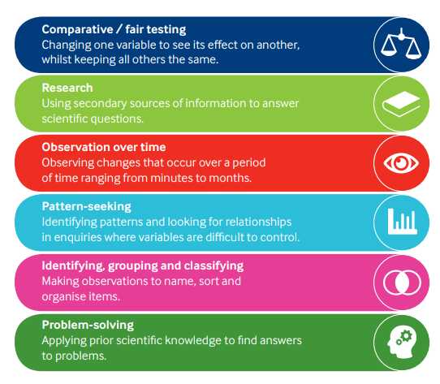

https://pstt.org.uk/resources/curriculum-materials/enquiry-approaches
WªoŒ„[i[n]ü ¡]c[¬e[n[t[i»i]c]a[l[l[þ ªa[t

Enquiry Skills

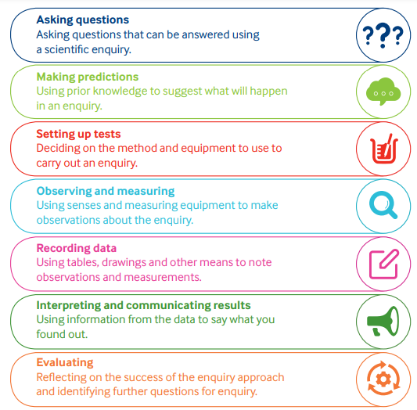

https://pstt.org.uk/resources/curriculum-materials/enquiry-skills

