
SAFEGUARDING DECLARATION
This school is committed to safeguarding and promoting the welfare of children and expects all staff and volunteers to share this commitment.
This means that we have a Child Protection Policy and procedures in place which we refer to in our prospectus. All staff (including supply staff, volunteers and governors) must ensure that they are aware of these procedures. Parents and carers are welcome to read the Policy on request.
Sometimes we may need to share information and work in partnership with other agencies when there are concerns about a child’s welfare. We will ensure that our concerns about our pupils are discussed with his/her parents/carers first unless we have reason to believe that such a move would be contrary to the child’s welfare.
Our Designated Safeguarding Leads (DSLs) are:
Miss S Isard
Deputy Headteacher
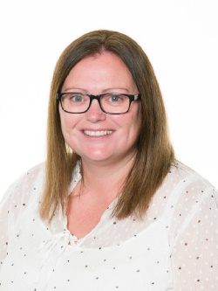

Mrs S Mackintosh Mrs H Mehta Miss N Booker Mrs A Shevel Miss R Woods Miss H Page Mrs A Heard
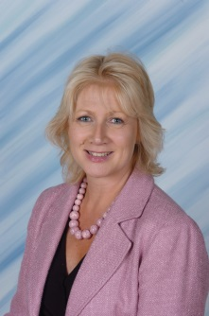
Headteacher SENDco Assistant Headteachers Class Teacher Crystal Club Home Sch Link

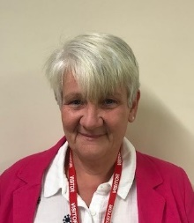
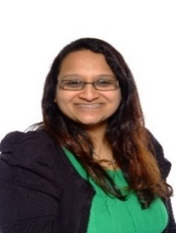
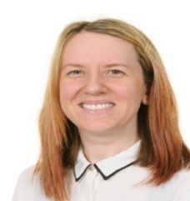
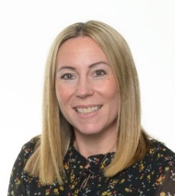
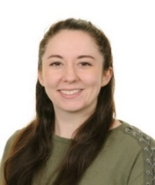
If you are concerned about a child’s welfare, please record your concern, and any observations or conversations heard, and report to the DSL or one of the DDSLs as soon as possible the same day. Do NOT conduct your own investigation. You can also email the DSL on: Sonia.isard@langshott.surrey.sch.uk

If your concerns relate to the actions or behaviour of a member of staff (which could suggest s/he is unsuitable to work with children) then you should report this to one of the CPLOs in confidence, who will refer the matter to the Headteacher (or the Safeguarding Governor if the concern relates to the Headteacher) who will consider what action to take.
Designated Safeguarding Lead: Miss S Isard
Deputy DSLs : Mrs S Mackintosh, Mrs H Mehta, Miss N Booker, Mrs A Shevel, Miss R Woods, Miss H Page and Mrs A Heard
Date 02.05.2025

