

Reception Computing – Online Safety
Outcome: Outcome: To know how to keep myself safe online.

Ideas and inspiration:

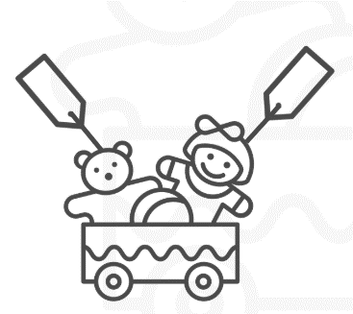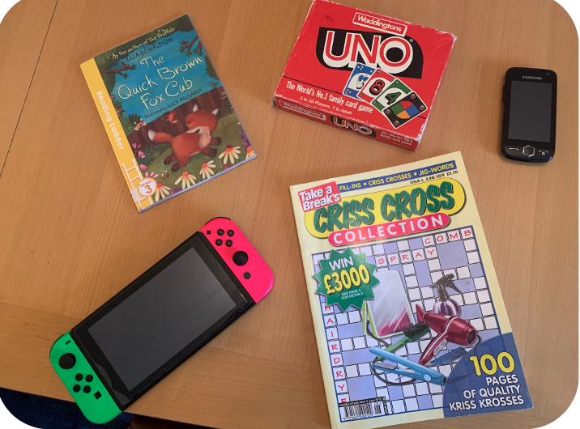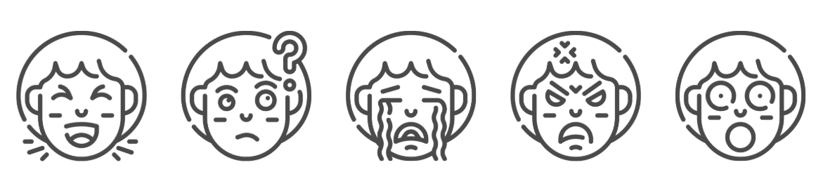

.

Self-image and identity |  | Emerging | Expected
 | I can recognise, online or offline, that anyone can say ‘no’ - ‘please stop’ - ‘I’ll tell’ - ‘I’ll ask’ to somebody who makes them feel sad, uncomfortable, embarrassed or upset.
Online Relationships |  | Emerging | Expected
 | I can recognise some ways in which the internet can be used to communicate.
 | I can give examples of how I (might) use technology to communicate with people I know.
Online reputation |  | Emerging | Expected
 | I can identify ways that I can put information on the internet.
Online bullying |  | Emerging | Expected
 | I can describe ways that some people can be unkind online.
 | I can offer examples of how this can make others feel.
Managing online information |  | Emerging | Expected
 | I can talk about how to use the internet as a way of finding information online.
 | I can identify devices I could use to access information on the internet.
Health, well-being and lifestyle |  | Emerging | Expected
 | I can identify rules that help keep us safe and healthy in and beyond the home when using technology and I can give some simple examples of these rules.
Privacy and security |  | Emerging | Expected
 | I can identify some simple examples of my personal information (e.g. name, address, birthday, age, location) and describe who would be trustworthy to share this information with; I can explain why they are trusted.
Copyright and ownership |  | Emerging | Expected
 | I know that work I create belongs to me and that I can name my work so that others know it belongs to me.

I can keep safe online by…

_________________________________________________________________________________________________

_________________________________________________________________________________________________

_________________________________________________________________________________________________

