

Year 5 Computing – Online Safety
Outcome: To demonstrate how to keep myself and others safe online and apply this to my online interactions in the real world.

Prior Knowledge
Explain how my online identity can be different to my offline identity. Describe positive ways for someone to interact with others online and understand how this will positively impact on how others perceive them. Explain that others online can pretend to be someone else, including my friends, and can suggest reasons why they might do this.
Give examples of how to be respectful to others online and describe how to recognise healthy and unhealthy online behaviours. Explain how content shared online may feel unimportant to one person but may be important to other people’s thoughts feelings and beliefs.
Describe how to find out information about others by searching online. Explain ways that some of the information about anyone online could have been created, copied or shared by others.
Recognise when someone is upset, hurt or angry online. Explain why people need to think carefully about how content they post might affect others, their feelings and how it may affect how others feel about them (their reputation).
Analyse information to make a judgement about probable accuracy and I understand why it is important to make my own decisions regarding content and that my decisions are respected by others. Explain why lots of people sharing the same opinions or beliefs online do not make those opinions or beliefs true. Explain that technology can be designed to act like or impersonate living things (e.g. bots) and describe what the benefits and the risks might be.
Explain how using technology can be a distraction from other things, in both a positive and negative way. Identify times or situations when someone may need to limit the amount of time they use technology e.g. I can suggest strategies to help with limiting this time.
Explain that internet use is never fully private and is monitored, e.g. adult supervision. Describe how some online services may seek consent to store information about me; know how to respond appropriately and who I can ask if I am not sure. Know what the digital age of consent is and the impact this has on online services asking for consent.
When searching on the internet for content to use, explain why I need to consider who owns it and whether I have the right to reuse it.
Give some simple examples of content which I must not use without permission from the owner, e.g. videos, music, images.
Ideas and inspiration:

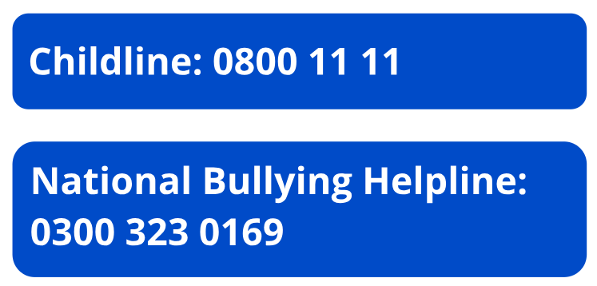

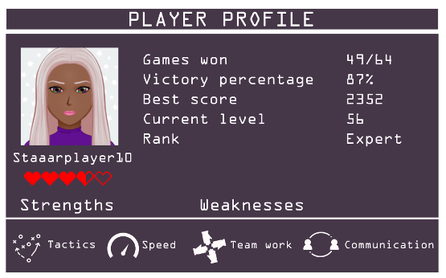

.

Developing Knowledge and Skills
Self-image and identity |  | Working Towards | Within | Securely Within | Above
 | I can explain how identity online can be copied, modified or altered.
 | I can demonstrate how to make responsible choices about having an online identity, depending on context.
Online Relationships |  | Working Towards | Within | Securely Within | Above
 | I can explain that there are some people I communicate with online who may want to do me or my friends harm. I can recognise that this is not my / our fault.
 | I can describe some of the ways people may be involved in online communities and describe how they might collaborate constructively with others and make positive contributions. (e.g. gaming communities or social media groups).
Online reputation |  | Working Towards | Within | Securely Within | Above
 | I can search for information about an individual online and summarise the information found. I can describe ways that information about anyone online can be used by others to make judgments about an individual and why these may be incorrect.
Online bullying |  | Working Towards | Within | Securely Within | Above
 | I can explain how anyone can get help if they are being bullied online and identify when to tell a trusted adult.  I can identify a range of ways to report concerns and access support both in school and at home about online bullying.  I can describe the helpline services which can help people experiencing bullying, and how to access them (e.g. Childline or The Mix).
Managing online information |  | Working Towards | Within | Securely Within | Above
 | I can explain what is meant by ‘being sceptical’; I can give examples of when and why it is important to be ‘sceptical’.  I can evaluate digital content and can explain how to make choices about what is trustworthy e.g. differentiating between adverts and search results.  I can explain key concepts including: information, reviews, fact, opinion, belief, validity, reliability and evidence.
Health, well-being and lifestyle |  | Working Towards | Within | Securely Within | Above
 | I can describe some strategies, tips or advice to promote health and wellbeing with regards to technology.
 | I recognise the benefits and risks of accessing information about health and well-being online and how we should balance this with talking to trusted adults and professionals.
Privacy and security |  | Working Towards | Within | Securely Within | Above
 | I can explain how many free apps or services may read and share private information (e.g. friends, contacts, likes, images, videos, voice, messages, geolocation) with others.
 | I can explain what app permissions are and can give some examples.
Copyright and ownership |  | Working Towards | Within | Securely Within | Above
 | I can assess and justify when it is acceptable to use the work of others.  I can give examples of content that is permitted to be reused and know how this content can be found online.

I can keep safe online by…

____________________________________________________________________________________________________

____________________________________________________________________________________________________

____________________________________________________________________________________________________

____________________________________________________________________________________________________

