

Year 4 Computing – Online Safety
Outcome: To demonstrate how to keep myself and others safe online.

Prior Knowledge
Explain what is meant by the term ‘identity’. Explain ways in which someone might change their identity depending on what they are doing online (e.g. gaming; using an avatar; social media) and why.
Explain what it means to ‘know someone’ online and why this might be different from knowing someone offline. Explain why someone may change their mind about trusting anyone with something if they feel nervous, uncomfortable or worried.
Explain how to search for information about others online. Explain the need to be careful before sharing anything personal.
Describe appropriate ways to behave towards other people online and why this is important. Give examples of how bullying behaviour could appear online and how someone can get support.
Demonstrate how to use key phrases in search engines to gather accurate information online.
Explain the difference between a ‘belief’, an ‘opinion’ and a ‘fact. and can give examples of how and where they might be shared online, e.g. in videos, memes, posts, news stories etc.
Explain why spending too much time using technology can sometimes have a negative impact on anyone. Explain why some online activities have age restrictions, why it is important to follow them and know who I can talk to if others pressure me to watch or do something online that makes me feel uncomfortable (e.g. age restricted gaming or web sites).
Describe simple strategies for creating and keeping passwords private. Give reasons why someone should only share information with people they choose to and can trust. Explain that if they are not sure or feel pressured then they should tell a trusted adult.
Explain why copying someone else’s work from the internet without permission isn’t fair and can explain what problems this might cause.
Ideas and inspiration:

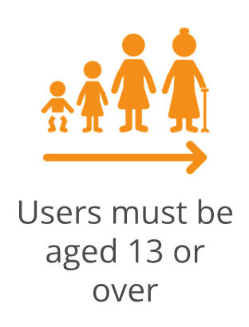


.

Developing Knowledge and Skills
Self-image and identity |  | Working Towards | Within | Securely Within | Above
 | I can explain how my online identity can be different to my offline identity.  I can describe positive ways for someone to interact with others online and understand how this will positively impact on how others perceive them.  I can explain that others online can pretend to be someone else, including my friends, and can suggest reasons why they might do this.
Online Relationships |  | Working Towards | Within | Securely Within | Above
 | I can give examples of how to be respectful to others online and describe how to recognise healthy and unhealthy online behaviours.
 | I can explain how content shared online may feel unimportant to one person but may be important to other people’s thoughts feelings and beliefs.
Online reputation |  | Working Towards | Within | Securely Within | Above
 | I can describe how to find out information about others by searching online.  I can explain ways that some of the information about anyone online could have been created, copied or shared by others.
Online bullying |  | Working Towards | Within | Securely Within | Above
 | I can recognise when someone is upset, hurt or angry online.
 | I can explain why people need to think carefully about how content they post might affect others, their feelings and how it may affect how others feel about them (their reputation).
Managing online information |  | Working Towards | Within | Securely Within | Above
 | I can analyse information to make a judgement about probable accuracy and I understand why it is important to make my own decisions regarding content and that my decisions are respected by others.
I can explain why lots of people sharing the same opinions or beliefs online do not make those opinions or beliefs true.
I can explain that technology can be designed to act like or impersonate living things (e.g. bots) and describe what the benefits and the risks might be.

Health, well-being and lifestyle |  | Working Towards | Within | Securely Within | Above
 | I can explain how using technology can be a distraction from other things, in both a positive and negative way.
 | I can identify times or situations when someone may need to limit the amount of time they use technology e.g. I can suggest strategies to help with limiting this time.
Privacy and security |  | Working Towards | Within | Securely Within | Above
 | I can explain that internet use is never fully private and is monitored, e.g. adult supervision.
I can describe how some online services may seek consent to store information about me; I know how to respond appropriately and who I can ask if I am not sure.
I know what the digital age of consent is and the impact this has on online services asking for consent.

Copyright and ownership |  | Working Towards | Within | Securely Within | Above
 | When searching on the internet for content to use, I can explain why I need to consider who owns it and whether I have the right to reuse it.  I can give some simple examples of content which I must not use without permission from the owner, e.g. videos, music, images.

I can keep safe online by…

____________________________________________________________________________________________________

____________________________________________________________________________________________________

____________________________________________________________________________________________________

____________________________________________________________________________________________________

____________________________________________________________________________________________________

