

Year 3 Computing – Online Safety
Outcome: To know how to keep myself and others safe online.

Prior Knowledge
Explain how other people may look and act differently online and offline. Give examples of issues online that might make someone feel sad, worried, uncomfortable or frightened; give examples of how they might get help.
Describe different ways to ask for, give, or deny my permission online and can identify who can help me if I am not sure. Explain why I have a right to say ‘no’ or ‘I will have to ask someone’.
Explain who can help me if I feel under pressure to agree to something I am unsure about or don’t want to do.
Explain how information put online about someone can last for a long time.
Describe how anyone’s online information could be seen by others.
Explain what bullying is, how people may bully others and how bullying can make someone feel.
Talk about how anyone experiencing bullying can get help.
Explain what voice activated searching is and how it might be used, and know it is not a real person (e.g. Alexa, Google Now, Siri). Explain the difference between things that are imaginary, ‘made up’ or ‘make believe’ and things that are ‘true’ or ‘real’. Explain why some information I find online may not be real or true.
Explain simple guidance for using technology in different environments and settings e.g. accessing online technologies in public places and the home environment.
Say how those rules / guides can help anyone accessing online technologies.
Explain how passwords can be used to protect information, accounts and devices.
Explain and give examples of what is meant by ‘private’ and ‘keeping things private’. Describe and explain some rules for keeping personal information private (e.g. creating and protecting passwords).
Recognise that content on the internet may belong to other people. I can describe why other people’s work belongs to them.
Ideas and inspiration:

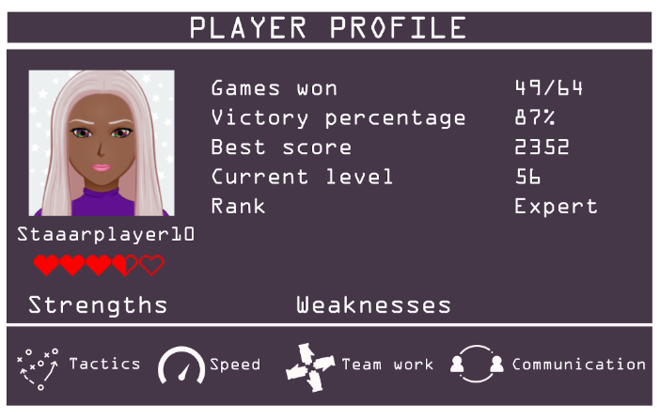
.

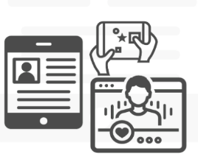

Developing Knowledge and Skills
Self-image and identity |  | Working Towards | Within | Securely Within | Above
 | I can explain what is meant by the term ‘identity’. I can explain ways in which someone might change their identity depending on what they are doing online (e.g. gaming; using an avatar; social media) and why.
Online Relationships |  | Working Towards | Within | Securely Within | Above
 | I can explain what it means to ‘know someone’ online and why this might be different from knowing someone offline.
 | I can explain why someone may change their mind about trusting anyone with something if they feel nervous, uncomfortable or worried.
Online reputation |  | Working Towards | Within | Securely Within | Above
 | I can explain how to search for information about others online.  I can explain the need to be careful before sharing anything personal.
Online bullying |  | Working Towards | Within | Securely Within | Above
 | I can describe appropriate ways to behave towards other people online and why this is important.
 | I can give examples of how bullying behaviour could appear online and how someone can get support.
Managing online information |  | Working Towards | Within | Securely Within | Above
 | I can demonstrate how to use key phrases in search engines to gather accurate information online.
 | I can explain the difference between a ‘belief’, an ‘opinion’ and a ‘fact. and can give examples of how and where they might be shared online, e.g. in videos, memes, posts, news stories etc.
Health, well-being and lifestyle |  | Working Towards | Within | Securely Within | Above
 | I can explain why spending too much time using technology can sometimes have a negative impact on anyone.
 | I can explain why some online activities have age restrictions, why it is important to follow them and know who I can talk to if others pressure me to watch or do something online that makes me feel uncomfortable (e.g. age restricted gaming or web sites).
Privacy and security |  | Working Towards | Within | Securely Within | Above
 | I can describe simple strategies for creating and keeping passwords private.
 | I can give reasons why someone should only share information with people they choose to and can trust. I can explain that if they are not sure or feel pressured then they should tell a trusted adult.
Copyright and ownership |  | Working Towards | Within | Securely Within | Above
 | I can explain why copying someone else’s work from the internet without permission isn’t fair and can explain what problems this might cause.

I can keep safe online by…

____________________________________________________________________________________________________

____________________________________________________________________________________________________

____________________________________________________________________________________________________

____________________________________________________________________________________________________

____________________________________________________________________________________________________

