

Year 1 Computer Science

Prior Knowledge
- Making links and noticing patterns
- Developing ideas of grouping, sequences, cause and effect
- Order and sequence familiar events.

.

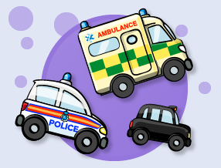

.

On the move outcome: use clear instructions to create programs
Debug |  | Working Towards | Within | Securely Wthin | Above
 | - Combine start events and click events to program cars and emergency vehicles in an animated traffic scene.
Sequence |  | Working Towards | Within | Securely Wthin | Above
 | - Use code to make objects move when they are clicked on.
 | - Combine start events and click events to make a simple game.
Logical reasoning |  | Working Towards | Within | Securely Wthin | Above
 | - Understand that when a computer does something it is following instructions called ‘code’.
Simple inputs outcome: Combine input events to create apps and programs
Debug |  | Working Towards | Within | Securely Wthin | Above
 | - Combine start events and click events to program cars and emergency vehicles in an animated traffic scene.
Sequence |  | Working Towards | Within | Securely Wthin | Above
- Use code to make objects move when they are clicked on.
- Combine start events and click events to make a simple game.
 |  | Working Towards | Within | Securely Wthin | Above
 | - Understand that when a computer does something it is following instructions called ‘code’.
Highlights: ___________________________________________________________________________________

____________________________________________________________________________________________

Glossary

Vocabulary | Word class | Definition
action | noun | the fact or process of doing something.
characters | noun | a symbol representing a letter or number.
create | verb | cause (something) to happen as a result of one's actions.
disappear | verb | be lost or go missing.
object | noun | a description of anything known to a computer.
program | noun | a series of coded instructions to control the operation.
realistic | adjective | having or showing a sensible and practical idea of what can be achieved or expected.


