

Year R Computer Science

Prior Knowledge
- Understand position through words alone – for example, “The bag is under the table,” – with no pointing.
- Describe a familiar route.
- Discuss routes and locations, using words like ‘in front of’ and ‘behind’.

.

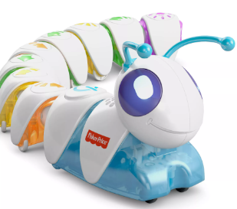

.

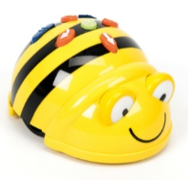

On the move outcome: to correctly programme a bee bot or code – a –pillar to reach a specified destination
Debug |  | Emerging | Expected
 | - Combine a sequence of directions to programme a bee bot or code – a – pillar
Sequence |  | Emerging | Expected
 | - Use a sequence of directions to move the device around a story map
Logical reasoning |  | Emerging | Expected
 | - Understand that the device is following the instructions we give it.
Highlights: ___________________________________________________________________________________

____________________________________________________________________________________________

Glossary

Vocabulary | Word class | Definition
Device | noun | A thing made or adapted for a particular purpose, especially a piece of mechanical or electronic equipment.
Direction | noun | A course along which someone or something moves.
Button | noun | A small device on a piece of electrical or electronic equipment which is pressed to operate it.

