

Year 4 Computer Science

Prior Knowledge
- Write code that uses a timer to create a sequence of traffic lights turning on and off.
- Write a computer program where different pieces of code execute in a particular sequence.
- Write code that uses a timer to create a sequence of events.
- Create a program that uses sequences for two different objects moving on the screen.


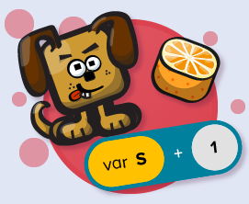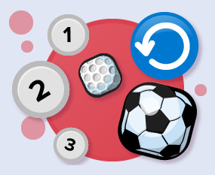

.

Introduction to variables outcome: create simple programs using variables
Sequence |  | Working Towards | Within | Securely Wthin | Above
 | - Use variables to keep track of the score in a game that uses conditional events.
 | - Use a variable to keep track of the score in a game where the score increases, decreases or resets when different conditions are met.
 | - Learn how to use multiple different variables and to set the value of a variable.
Logical reasoning |  | Working Towards | Within | Securely Wthin | Above
 | - Understand how a variable can be used to keep track of the score in a game.

Repetition and loops outcome: when coding, use repetition and loops
Debug |  | Working Towards | Within | Securely Wthin | Above
 | - Write the code to program a rocket to orbit round the spinning Moon, using the concepts of loops, regular or infinite repetition, and ‘if statement’ blocks.
 | - Write code that uses nested loops to create a car-driving program.
Sequence |  | Working Towards | Within | Securely Wthin | Above
 | - Use loops, a variable and if statements to create an animated scene of hot air balloons performing a repeating pattern in the sky.
 | - Use a loop to do something repeatedly in a program.
 | - Designs simple algorithms using loops and selection, i.e. if statements. (AL)
How will my computer learning in Year 4 help me with other learning? ______________________________________
______________________________________________________________________________________________ Highlights: _____________________________________________________________________________________

______________________________________________________________________________________________

Glossary

Vocabulary | Word class | Definition
animated | verb | give (a film or character) the appearance of movement using animation techniques.
complex | adjective | consisting of many different and connected parts.
concepts | noun | a plan or intention.
efficient | adjective | achieving maximum productivity with minimum wasted effort or expense.
rotation | noun | the action of rotating about an axis or centre.
specify | verb | identify clearly and definitely.
system | noun | a set of things working together as parts of a mechanism or an interconnecting network; a complex whole.
value | noun | the regard that something is held to deserve; the importance, worth, or usefulness of something.
variable | adjective | not consistent or having a fixed pattern; liable to change.



