

Year 2 Computer Science

Prior Knowledge
- Combine start events and click events to program cars and emergency vehicles in an animated traffic scene.
- Use code to make objects move when they are clicked on.
- Combine start events and click events to make a simple game.
- Understand that when a computer does something it is following instructions called ‘code’.



.

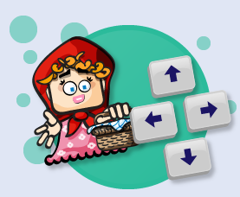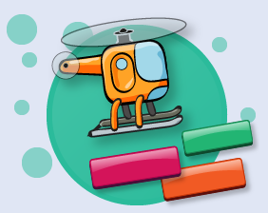

.

Buttons and instructions outcome: use the keyboard to control objects on screen
Debug |  | Working Towards | Within | Securely Wthin | Above
 | - Write code where buttons can be used to make an object move around the screen.
 | - Write code where buttons are used to move a monster around and eat (hide) fruit.
Sequence |  | Working Towards | Within | Securely Wthin | Above
 | - Write the code for a simple game where buttons are used to move an object around.
 | - Write the code for a simple game where buttons are used to move an object around and cast magic ‘disappearing spell’.

Different sorts of inputs outcome: write codes to instruct objects
Debug |  | Working Towards | Within | Securely Wthin | Above
 | - Write code that makes an object move around the screen when keys are pressed.
 | - Write code that makes an object change direction when different keys on the keyboard are pressed.
 | - Write code that makes an object change direction when the pointer is pressed and released.
Sequence |  | Working Towards | Within | Securely Wthin | Above
 | - Write code where different inputs can be used to make objects move and disappear.
Logical reasoning |  | Working Towards | Within | Securely Wthin | Above
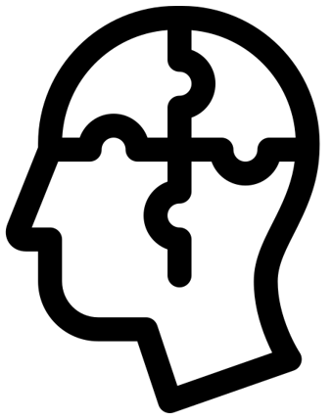 | - Make objects perform different actions when keys are pressed on the keyboard.
How did my learning in Year 1 help me? _____________________________________________________________
______________________________________________________________________________________________ Highlights: _____________________________________________________________________________________

______________________________________________________________________________________________

Glossary

Vocabulary | Word class | Definition
change | verb | make (someone or something) different.
code | noun | program instructions.
combine | verb | join or merge to form a single unit
direction | noun | a course along which someone or something moves.
event | noun | a single occurrence of a process
logically | adverb | in a way that is Securely Wthin or sensible
movement | noun | an act of moving.
objects | noun | a material thing that can be seen and touched.
perform | verb | carry out, accomplish, or fulfil
respond | verb | do something as a reaction to someone or something.
scene | noun | the place where an incident in real life or fiction occurs or occurred.



