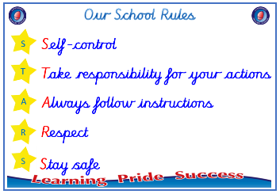
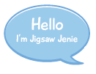


EYFS

PSHE – Changing Me
Outcome : Timeline Reflect on how I have changed since I
was a baby.



Ideas and inspiration

Growing and changing

Body parts

Vocabulary:
- baby
- adult
- changes
- excited
- worried
- male
- female
- penis
- testicle
- vagina
- body parts
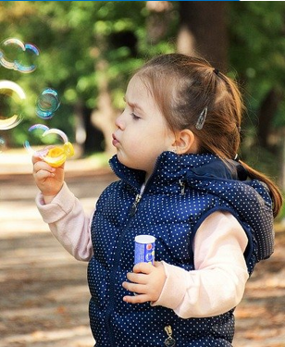
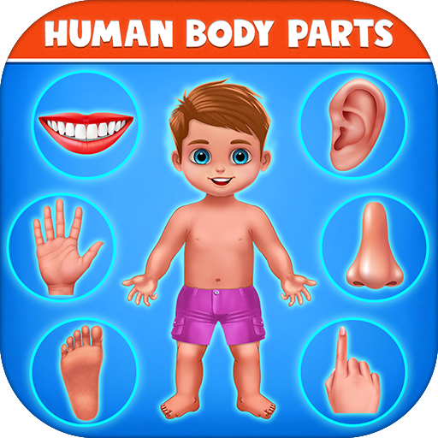

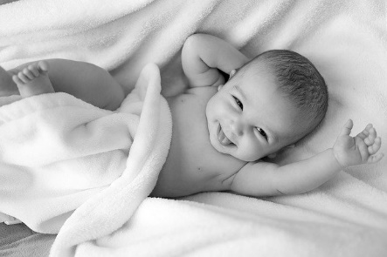

Take responsibility for your actions
 |  | Emerging | Expected
 | - To be able to say that some things I can do and foods I can eat are healthy.
 | - To talk about my worries and / or the things I am looking forward to about being in Year 1.
 | - To share my memories of the best bits of this year in Early Years.
Respect
 |  | Emerging | Expected
 | - To be able to name parts of the body.
 | - To understand that we all grow from babies to adults.
Highlights: ___________________________________________________________________________________

____________________________________________________________________________________________

