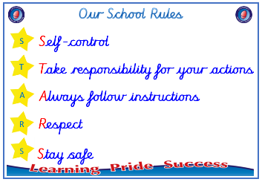
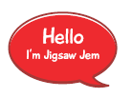


Year 6

PSHE – Changing Me
Outcome: T Shirts. Reflect on my best moments and what
I am looking forward to.

.

:



Prior skills
Prior skills from Year 5
     | - Express how I feel about the changes that will happen to me during puberty.
 | - Understand that puberty is a natural process that happens to everybody and that it will be ok for me.
 | - Know how to develop my own self esteem.
 | - Be aware of my own self-image and how my body image fits into that.
 | - Explain how a girl’s and boy’s bodies change during puberty and understand the importance of looking after yourself physically and emotionally.
 | - Understand that sexual intercourse can lead to conception and that is how babies are usually made.
 | - Understand that sometimes people need IVF to help them have a baby.
 | - Identify what I am looking forward to about becoming a teenager and understand this brings growing responsibilities (age of consent).

Ideas and inspiration

Girlfriend and boyfriend

Secondary School

Body image
Vocabulary:
- wet dreams
- semen
- pubic hair
- clitoris
- placenta
- labour
- contractions
- cervix
- midwife
- sexting
- negative body talk
- mental health




Take responsibility for your actions
 |  | Working Towards | Within | Securely Within | Above
 | - To be aware of and know how to develop my own self-image and how my body fits into that.
 | - To be aware of the importance of a positive self –esteem and what I can do to develop it.
 | - To identify what I am looking forward to and what worries me about the transition secondary school.
Respect
 |  | Working Towards | Within | Securely Within | Above
 | - To explain how girls’ and boys’ bodies change during puberty and understand the importance of looking after myself physically and emotionally.
 | - Describe how a baby develops from conception to birth.
 | - To understand how being physically attracted to someone changes the nature of the relationship and what it might mean about having a girlfriend/boyfriend.
 | - To understand that respect for one another is essential in a boyfriend/girlfriend relationship and that I should not feel pressured into doing something I don’t want to.
I have changed since I was in Year 5 because ___________________________________________________________
________________________________________________________________________________________________
Highlights: _______________________________________________________________________________________
________________________________________________________________________________________________

