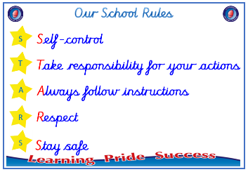
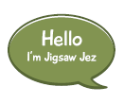


Year 5

PSHE – Changing Me
Outcome: Change Cards Advise a teenager about their
upcoming changes.

:

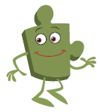

Prior skills
Prior skills from Year 4
   | - Understand that having a baby is a personal choice and can express how I feel about having children when I am an adult.
 | - Know how the circle of change works and can apply it to changes I want to make in my life.
 | - Identify changes that have been outside of my control and that I will learn to accept them.
 | - Identify what I am looking forward to when I move to my next class
 | - Understand that some of my personal characteristics have come from my birth parents.
 | - Describe how a girl’s body changes in order for her to be able to have babies when she is an adult.
 | - Have strategies to help me cope with changes I will experience during puberty.

Ideas and inspiration
Self imagenv
Ivf (In vitro Fertilisation }

How babies are made

Trophy of Celebration
Vocabulary:
- erection
- ejaculation
- wet dream
- conception
- making love
- sexual intercourse
- fallopian tub
- embryo
- umbilical cord
- contraception
- fertility treatment (IVF),
- body image
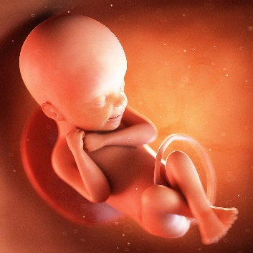
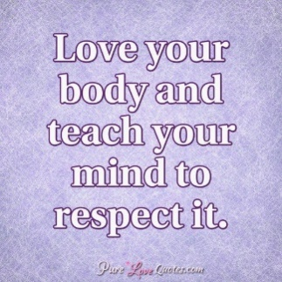
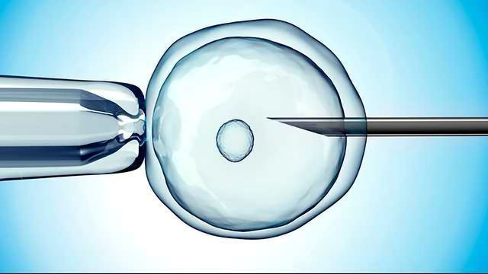

Take responsibility for your actions
 |  | Working Towards | Within | Securely Within | Above
 | - To express how I feel about the changes that will happen to me during puberty.
 | - To understand that puberty is a natural process that happens to everybody and that it will be ok for me.
 | - To know how to develop my own self esteem.
Respect
 |  | Working Towards | Within | Securely Within | Above
 | - To be aware of my own self-image and how my body image fits into that.
 | - To explain how a girl’s and boy’s bodies change during puberty and understand the importance of looking after yourself physically and emotionally
 | - To understand that sexual intercourse can lead to conception and that is how babies are usually made.
 | - To also understand that sometimes people need IVF to help them have a baby.
Safe
 |  | Working Towards | Within | Securely Within | Above
 | - To identify what I am looking forward to about becoming a teenager and understand this brings growing responsibilities (age of consent).

I have changed since I was in Year 4 because ___________________________________________________________
________________________________________________________________________________________________
Highlights: _______________________________________________________________________________________
________________________________________________________________________________________________

