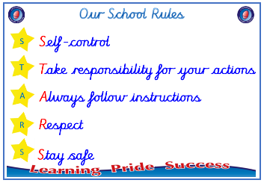
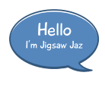


Year 4

PSHE – Changing Me

Outcome: Circles of Change Think about a change I would like to

make in the next academic year.

:

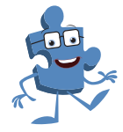

Prior skills
Prior skills from Year 3
   | - Understand that in humans and animals lots of changes happen between conception and growing up and that usually it is the female who has the baby.
 | - Understand how babies grow and develop in the mother’s uterus including what a baby needs to live and grow.
 | - Identify what I am looking forward to when I move to my next class.
 | - Start to recognise stereotypical ideas I might have about parenting and family roles.
 | - Express how I feel about the changes happening to me and how I feel when my ideas are challenged
 | - Express how I might feel if I had a new baby in the family.
 | - Understand that boys’ and girls’ bodies need to change so that when they grow up their bodies can make babies.
 | - Identify how boys’ and girls’ bodies change on the outside and on the inside.

Vocabulary:
- personal
- unique
- making love
- having sex
- sexual intercourse
- fertilise
- conception
- puberty
- menstruation
- periods
Ideas and inspiration
Changes

Trophy of Celebration
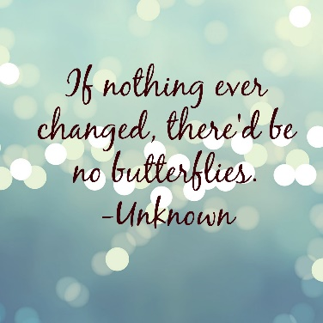
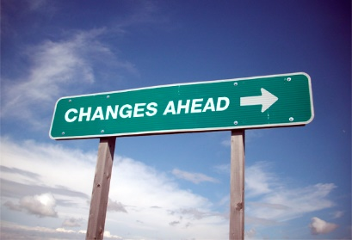

Take responsibility for your actions
 |  | Working Towards | Within | Securely Within | Above
 | - To understand that having a baby is a personal choice and can express how I feel about having children when I am an adult.
 | - To know how the circle of change works and can apply it to changes I want to make in my life.
 | - To identify changes that have been outside of my control and that I will learn to accept them.
 | - To identify what I am looking forward to when I move to my next class.
Respect
 |  | Working Towards | Within | Securely Within | Above
 | - To understand that some of my personal characteristics have come from my birth parents and this happen because I am made from the joining of their egg and sperm.
 | - To describe how a girl’s body changes in order for her to be able to have babies when she is an adult.
 | - To have strategies to help me cope with the physical and emotional changes I will experience during puberty.

I have changed since I was in Year 3 because ___________________________________________________________
________________________________________________________________________________________________
Highlights: _______________________________________________________________________________________
________________________________________________________________________________________________

