
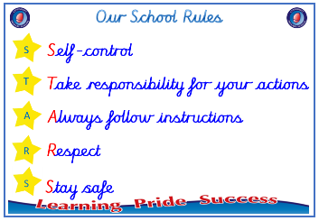


Year 3

PSHE – Changing Me
Outcome: Ribbon mobiles Identify something I am looking
forward to, changes I will go through and any worries I have.

:



Prior skills
Prior skills from Year 2
     | - Understand there are some changes that are outside my control and to recognise how I feel about this
 | - Recognise cycles of life in nature and understand the process of growing from young to old.
 | - Identify people I respect who are older than me.
 | - Understand that there are different types of touch and tell you which ones I like and don’t like.
 | - Recognise the physical differences between boys and girls, use the correct names for parts of the body.
- Appreciate that some parts of my body are private.
Vocabulary:
- uterus
- womb
- nutrients
- survive
- affection
- puberty
- ovaries
- egg
- ovum / ova
- stereotypes

Ideas and inspiration
Growing up A baby growing in the uterus

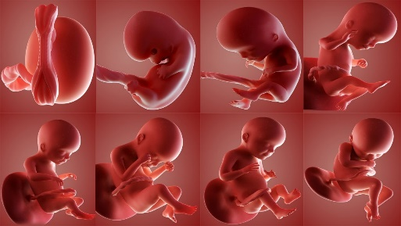
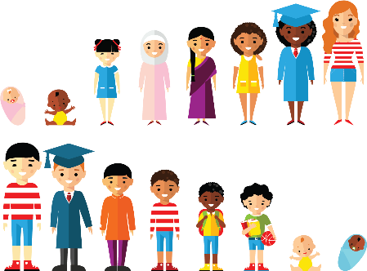

Take responsibility for your actions
 |  | Working Towards | Within | Securely Within | Above
 | - To understand that in humans and animals lots of changes happen between conception and growing up and that usually it is the female who has the baby.
 | - To understand how babies grow and develop in the mother’s uterus including what a baby needs to live and grow.
 | - To identify what I am looking forward to when I move to my next class.
Respect
 |  | Working Towards | Within | Securely Within | Above
 | - To start to recognise stereotypical ideas I might have about parenting and family roles.
 | - To express how I feel about the changes happening to me and how I feel when my ideas are challenged.
 | - To express how I might feel if I had a new baby in the family.
 | - To understand that boys’ and girls’ bodies need to change so that when they grow up their bodies can make babies.
 | - To identify how boys’ and girls’ bodies change on the outside and on the inside.
I have changed since I was in Year 2 because ___________________________________________________________
________________________________________________________________________________________________
Highlights: _______________________________________________________________________________________

