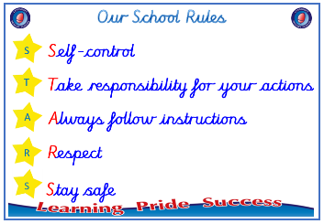
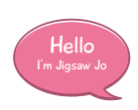


Year 2

PSHE – Changing Me
Leaf mobile Reflect on how I feel about changes and about
an older person I respect.

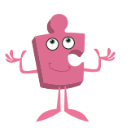

Prior skills
Prior skills from Year 1
     | - Understand that changes happen as we grow and that this is ok.
 | - Know that sometimes changes will happen whether I want them to or not
 | - Understand that every time I learn something new I change a little bit.
 | - Start to understand the life cycle of animals and humans.
 | - Be able to tell you some things about me that have changed about me and some things that have stayed the same.
 | - Understand that growing up is natural and that everybody grows at different rates.
 | - Identify the parts of the body that make boys different to girls and using the correct names these.
 | - Respect my body and understand which parts are private and why.

Ideas and inspiration
Some parts of my body are private
People older than me

Growing from young
to old

Vocabulary:
- respect
- appearance
- physical
- independent
- freedom
- responsibilities
- public
- private
- touch
- like
- dislike
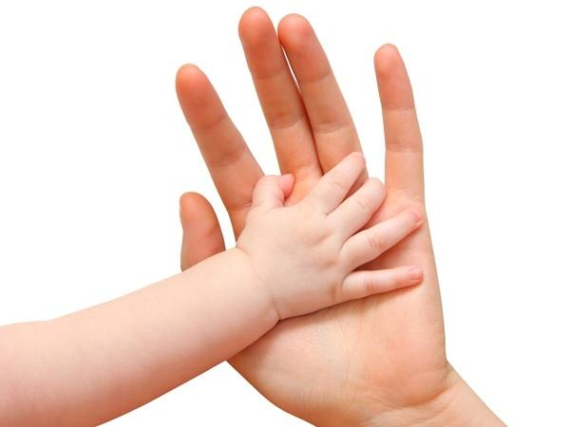




Take responsibility for your actions
 |  | Working Towards | Within | Securely Within | Above
 | - To understand there are some changes that are outside of my control and to recognise how I feel about this.
Respect
 |  | Working Towards | Within | Securely Within | Above
 | - To recognise cycles of life in nature and understand the process of growing from young to old.
 | - To identify people I respect who are older than me.
 | - To understand that there are different types of touch and tell you which ones I like and don’t like.
 | - To recognise the physical differences between boys and girls, use the correct names for parts of the body
Safe
 |  | Working Towards | Within | Securely Within | Above
 | - To appreciate that some parts of my body are private
I have changed since I was in Year 1 because ___________________________________________________________
________________________________________________________________________________________________
Highlights: _______________________________________________________________________________________
________________________________________________________________________________________________

