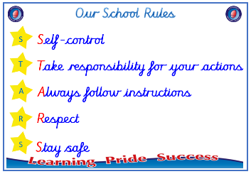
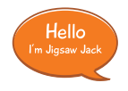


Year 1

PSHE – Changing Me
Outcome: Flower of change Reflect on something that has
helped me to grow.
Prior skills
Prior skills from EYFS
   | - Be able to say that some things I can do and foods I can eat are healthy.
 | - Talk about my worries and / or the things I am looking forward to about being in Year 1.
 | - Share my memories of the best bits of this year in Early Years.
 | - Be able to name parts of the body.
 | - Understand that we all grow from babies to adults.
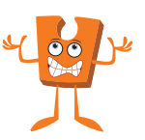

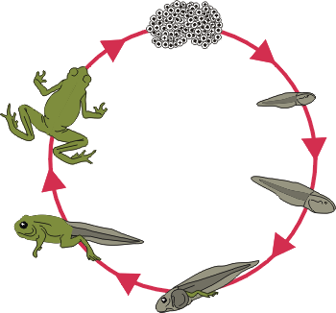
Ideas and inspiration
Life cycles

Growing and changing

Vocabulary:
- life cycle
- adulthood
- grown up
- anxious
- feelings
- mature
- vagina
- penis
- testicles
- vulva
- anus

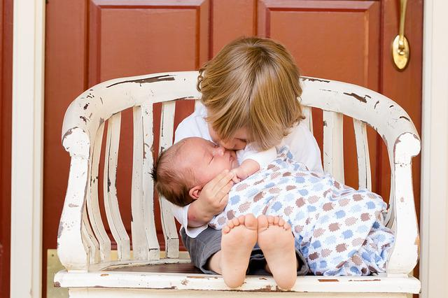
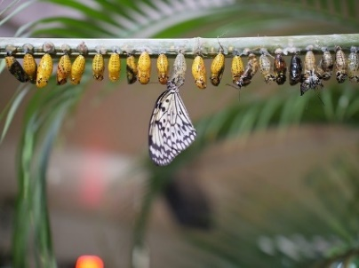

#

Take responsibility for your actions
 |  | Working Towards | Within | Securely Within | Above
 | - To understand that changes happen as we grow and that this is ok.
 | - Sometimes changes will happen whether I want them to or not.
 | - To understand that every time I learn something new I change a little bit.
Respect
 |  | Working Towards | Within | Securely Within | Above
 | - To start to understand the life cycle of animals and humans
 | - To be able to tell you some things about me that have changed and some things that have stayed the same.
 | - To understand that growing up is natural and that everybody grows at different rates.
 | - To identify the parts of the body that make boys different to girls and use the correct names for these.
Safe
 |  | Working Towards | Within | Securely Within | Above
 | - To respect my body and understand which parts are private and why.
I have changed since I was in Reception Class because _________________________________________________
_______________________________________________________________________________________________
Highlights: _______________________________________________________________________________________

