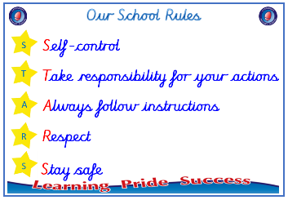
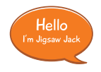


Year 1

PSHE – Celebrating Difference
Outcome: Gingerbread People. Reflect on differences, similarities
and looking after ourselves.

Prior skills
Prior skills from EYFS
     | - Know we are all different but the same in some ways.
 | - Identify something I am good at and to understand that everyone is good at different things.
 | - Understand that being different makes us all special.
 | - Know which words to use to stand up for myself when someone says or does something unkind.
 | - Say why my home is special to me.
 | - Discuss how to be a kind friend.


Vocabulary:
- similar
- same as
- different from
- difference
- bullying
- bullying behaviour
- deliberate
- on purpose
- unfair
- included
- celebration
- special
- unique

Ideas and inspiration

Gingerbread People
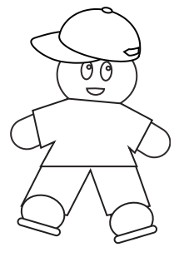



Take responsibility for your actions
 |  | Working Towards | Within | Securely Within | Above
 | - To be able to explain what a bully is.
Respect
 |  | Working Towards | Within | Securely Within | Above
 | - To be able to explain how I am different to my friends.
 | - To identify similarities and differences between people in my class.
Safe
 |  | Working Towards | Within | Securely Within | Above
 | - To know how to make new friends.
 | - To know who to talk to if I am unhappy or being bullied.
If I feel lonely at school, I can _______________________________________________________________________
________________________________________________________________________________________________
Highlights: _______________________________________________________________________________________
________________________________________________________________________________________________

