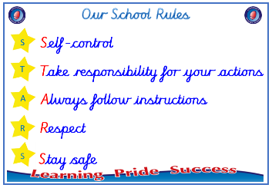
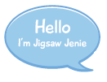


EYFS

PSHE – Celebrating Difference
Outcome: Paper chains Describe what makes us all special.



Vocabulary:
- boys
- girls
- similarities
- difference
- special
- stand up for
- kind
- unkind
- home
- friend.

Ideas and inspiration

Paper chains

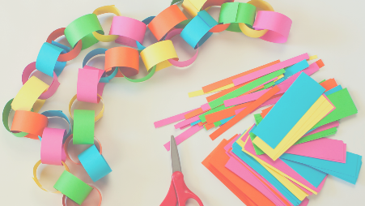


 |  | Emerging | Expected
 | - To know we are all different but the same in some ways
 |  | Emerging | Expected
 | - To identify something I am good at and to understand that everyone is good at different things.
 | - To understand that being different makes us all special.
 | - To know which words to use to stand up for myself when someone says or does something unkind.
 |  | Emerging | Expected
 | - To know which words to use to stand up for myself when someone says or does something unkind.
 | - To tell you how to be a kind friend.
I am a kind friend when ____________________________________________________________________________
________________________________________________________________________________________________
Highlights: _______________________________________________________________________________________
________________________________________________________________________________________________

