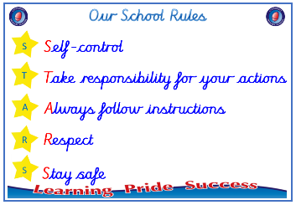
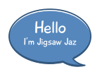


Year 4

PSHE – Celebrating Difference
Outcome: Picture Frames Demonstrate special features
of myself.

:



Prior skills
Prior skills from Year 3
     | - Know what it means to be a witness to bullying.
 | - Discuss a time when my words affected someone’s feelings and what the consequences were.
 | - Understand that everybody’s family is different but important to them.
 | - Understand that differences and conflict sometimes happen among family members.
 | - Recognise that some words are used in hurtful ways.
 | - Know that a witness can be a situation better or worse by what they do.

Vocabulary:
Character, assumption, judgement, surprised, different, appearance, accept, influence, opinion, attitude, secret, deliberate, on purpose, bystander, witness, problem solve, cyber bullying, text message, website troll, characteristics, physical features,
Ideas and inspiration

Picture frames

Trophy of Celebration



Take responsibility for your actions
 |  | Working Towards | Within | Securely Within | Above
 | - To know that sometimes bullying is hard to spot.
 | - To know what to do if I think bullying is going on but I am not sure.
Respect
 |  | Working Towards | Within | Securely Within | Above
 | - To be able to tell you of a time when my first impression of a person changed once I got to know them.
 | - To understand that sometimes we make assumptions based on what people look like.
 | - To identify what is special about me and value the ways I am unique.
Safe
 |  | Working Towards | Within | Securely Within | Above
- To explain why witnesses sometimes join in with
bullying and sometimes don’t tell.

I can help other people celebrate differences by ________________________________________________________
________________________________________________________________________________________________
Highlights: _______________________________________________________________________________________
________________________________________________________________________________________________

