

Outcome: to write a comic strip In Spanish based on Mafalda.
Prior skills
Prior skills.
 | To use a bilingual dictionary to translate words.
 | To apply the knowledge of Spanish sounds when talking in Spanish.
 | To listen for clues to meaning – tone of voice, key words.

Ideas and inspiration:  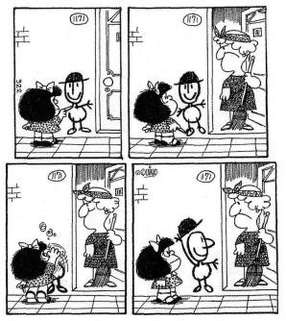 | Vocabulary:  Amigo Vive Odia  Le encanta  Apartamento Colegio  Sopa  Personality Humanity Paz  War | Vocabulary:  Comico Vago Charlatan Trabajador Sensato Inteligente Timido Leer Escuchar Hablar

Developing Knowledge
Vocabulary |  | Working  Towards | Within | Securely Within | Above
 | To know and use vocabulary for adjectives to describe  people.
To use possessive pronouns when talking about
ourselves and others (mi, tu, su…)
 | To use personal pronouns to talk about others (el, ella..)
GPS |  | Working  Towards | Within | Securely Within | Above
 | To recognise verbs in first and third person.
To use verbs relating to likes and dislikes (gustar,
odiar…)
Sentence Structure |  | Working  Towards | Within | Securely Within | Above
 | To recognise the word order in sentences when writing in Spanish.  ( Subject + Verb+ DO + Adjective)
Developing Skills
Writing – Reading – Listening - Speaking |  | Working  Towards | Within | Securely Within | Above
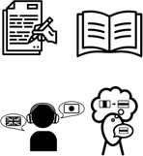 | Writing – Write a few sentences from memory, using  knowledge of words, texts and structure.
Reading – Read and understand the main points and
some detail from a short written passage.
Listening – Understand the main points and simple
opinions in spoken sources e.g. story, song or passage.
Speaking - Present to an audience e.g. role-play,
presentation, performance.

How does your current knowledge of English grammar (EGPS) help you with your Spanish learning? ________________

__________________________________________________________________________________________________

Highlights __________________________________________________________________________________________

___________________________________________________________________________________________________

