
Year 5 - Barcelona

Outcome: to create a travel article to persuade people to visit Barcelona.
Prior skills
Prior skills.
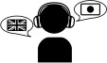 | To use a bilingual dictionary to translate words.
 | To apply the knowledge of Spanish sounds when talking in Spanish.
 | To follow instructions in Spanish.

Ideas and inspiration:  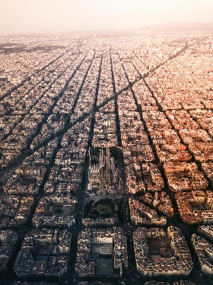  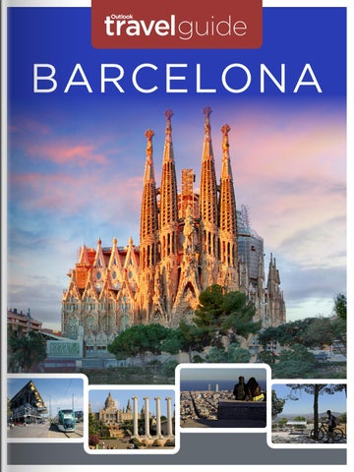 | Vocabulary:  Qué ver! / Qué hacer! Weather  Museo Visitar Comer Tener Norte Sur  Este – East Oeste - West  Interesante / Aburrida | Vocabulary:  Porque  Ruidosa / Tranquila Telesferico  Puente Ciudad Rio  Lugares emblematicos Escuela  Museo  Estacion de trenes Cafeteria

Developing Knowledge
Vocabulary |  | Working  Towards | Within | Securely Within | Above
 | To know and use vocabulary for places in a town.
To use verbs in the infinitive form to describe what to
do in a town.
 | To use adjectives to describe food and places.
GPS |  | Working  Towards | Within | Securely Within | Above
 | To use conjunctions to expand sentences.
 | To use “se puede + Infinitive” (One can + Inf)
Sentence Structure |  | Working  Towards | Within | Securely Within | Above
 | To recognise the word order when using possessive apostrophe in Spanish.
Developing Skills
Writing – Reading – Listening - Speaking |  | Working  Towards | Within | Securely Within | Above
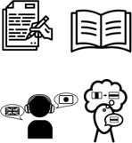 | Writing – Write a few sentences from memory, using  knowledge of words, texts and structure.
Reading – Read and understand the main points and
some detail from a short written passage.
Listening – Understand the main points and simple
opinions in spoken sources e.g. story, song or passage.
Speaking - Present to an audience e.g. role-play,
presentation, performance.

Are there any similarities with your learning in Geography to your learning in Spanish? ___________________________

__________________________________________________________________________________________________

Highlights: _________________________________________________________________________________________

__________________________________________________________________________________________________

