

Outcome: Write a short speech to describe ourselves to qualify for the ‘Langshott Spanish Wall of Fame’
Prior skills
Prior skills.
 | To use a bilingual dictionary to translate words.
 | To apply the knowledge of Spanish sounds when talking in Spanish.
 | To follow instructions in Spanish.

Ideas and inspiration:  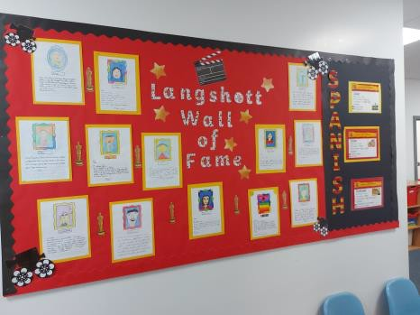 | Vocabulary:  Deliciosa Dulce  Pequeῆa Grande Pelo  Largo Corto Rizado Liso  Castaῆo Pelirojo | Vocabulary:  Barba Gafas Bajo Alto Y  Perro Gato Pájaro Pez  Conejo Caballo | Vocabulary:  Me llamo Vivo  Tengo  No tengo El  La Los Las  Cómo Dónde Cuántos

Developing Knowledge
Vocabulary |  | Working  Towards | Within | Securely Within | Above
 | To ask and answer questions about personal  information.
 | To use vocabulary for pets.
 | To use adjectives for personal description.
GPS |  | Working  Towards | Within | Securely Within | Above
 | To use the determiner “the” in all its forms (el, la, los,  las)
 | To use “I have – tengo” to talk about myself.
 | To apply the plural rules to nouns.
Sentence Structure |  | Working  Towards | Within | Securely Within | Above
 | To recognise and write negative sentences.
 | To use correct punctuation.
 | To identify word order in noun phrases.
Developing Skills
Writing – Reading – Listening - Speaking |  | Working  Towards | Within | Securely Within | Above
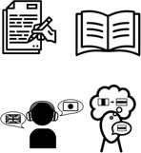 | Writing – Read, copy and write independently using  taught vocabulary.
Reading – Focus on correct pronunciation and
intonation.
Listening – Listen attentively to spoken language and
showing understanding by joining in and responding.
Speaking - Engage in conversations; ask and answer
questions.
How will you try to use your new learning outside of school? ________________________________________________

_________________________________________________________________________________________________

Highlights: ____

