

Outcome: to engage in a basic conversation in Spanish in a television interview or podcast.
Prior skills
Prior skills.
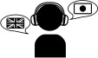 | To use the dictionary to find out the meaning of words.
 | To appreciate stories, songs and rhymes.
 | To focus on correct pronunciation.

  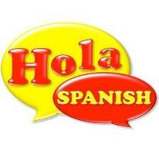  Ideas and inspiration: | Vocabulary:  Rojo verde Azul Negro Blanco  Amarillo Rosa  Cabeza Hombros Rodilla Pies | Vocabulary:  Ojos Orejas Boca Nariz Tengo  Uno, Dos, Tres, Cuatro Cinco, seis, siete, ocho Nueve, diez  Lunes, Martes, Miercoles Jueves, Viernes, Sabado Domingo

Developing Knowledge
Vocabulary |  | Working  Towards | Within | Securely Within | Above
 | To know how to pronounce the letter names and  sounds in Spanish.
 | To use simple greetings (How are you? ¿Qué tal?)
To know and use vocabulary for numbers, colours and
body parts.
GPS |  | Working  Towards | Within | Securely Within | Above
 | To recognise 3rd person verb “to be” – is / es
 | To recognise masculine & feminine of nouns.
Sentence Structure |  | Working  Towards | Within | Securely Within | Above
 | To identify and use personal pronoun (Mi-My) when talking about family.
 | To match noun/adjective by number.
Developing Skills
Writing – Reading – Listening - Speaking |  | Working  Towards | Within | Securely Within | Above
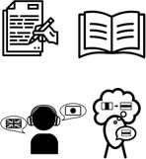 | Writing – Broaden vocabulary – write words by  memory.
 | Reading – Follow song lyrics.
Listening – Showing understanding when listening by
joining in and responding.
Speaking - Engage in conversations; ask and answer
questions.

How does your knowledge of English grammar (EGPS) help you with your Spanish learning? _______________________

__________________________________________________________________________________________________

Highlights: _________________________________________________________________________________________

__________________________________________________________________________________________________

