Parent guide to Reading at Langshott

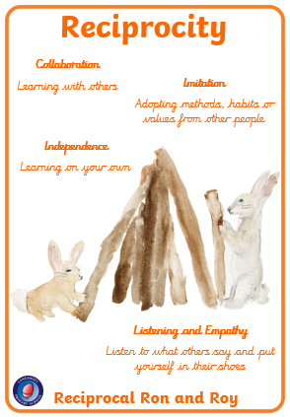
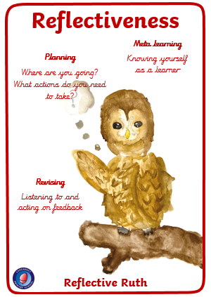
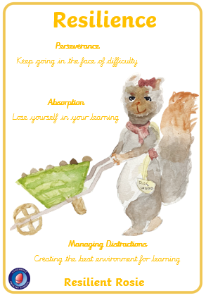
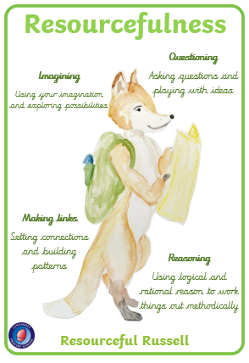



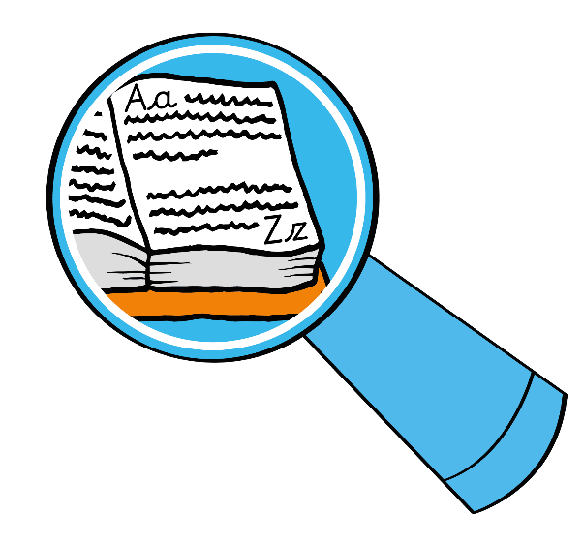
Can you find any adjectives used to describe _____?

How does this word/ description make you feel?

Can you think of another way of saying ____?

Why is this word written in bold/italics/ capital letters?

Vocabulary questions to ask when your child is reading…
Why did the author use the word ____ to describe _____?
Can you give me another sentence with the word ____ in it?

What impact has the author created by repeating the word/ phrase _____?

How/where can we find out the meaning of this word?
What does this word/sentence tell you about ______?

Can you find a word/ sentence that supports what you have just said about _____?

What do you remember about _____?

Which is your favourite/worst/ funniest/scariest part of the story? Why?

Can you think of a different title for this story/poem/non-fiction text/section/chapter?
Who is/are the main character(s) in the story?
Retrieval questions to ask when your child is reading…
Where/when is the story set?
Is there a good/bad character? Who is it? How can you tell?
Who is telling us the story?
How does the story end?
What do you think is happening here?
Why is this story/ poem/non-fiction text/section/chapter called?

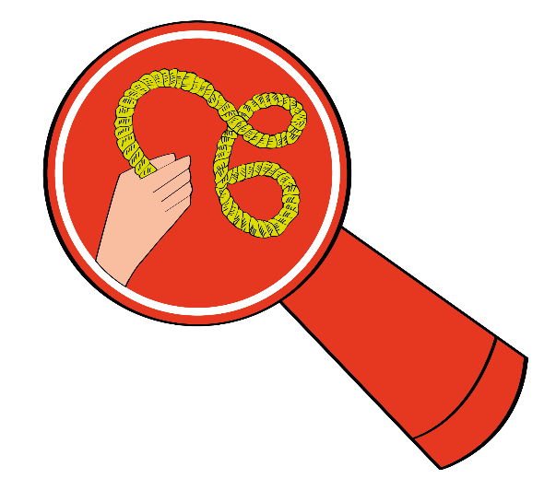

What can we guess about where/when this is taking place?
Why do you think _____?
Can you explain why ________?

How did you feel when
________?

Is there anything you’ve just read which reminds you of something that has happened to you, or someone you know? Why? How?
Can you describe how you felt when ____? Why?
What do you think ____ is saying/thinking/ feeling at this point? Why?
Why does the author use the word ___ here?
What do you think the author meant when ____?
What do you think the word ___ means? Why do you think that How do you know?
Inference questions to ask when your child is reading…

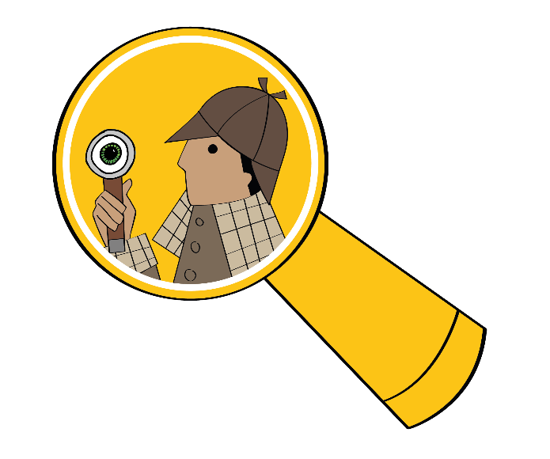

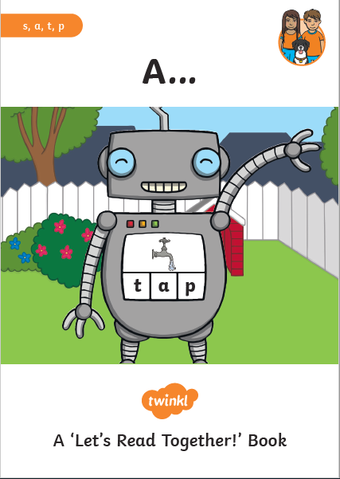
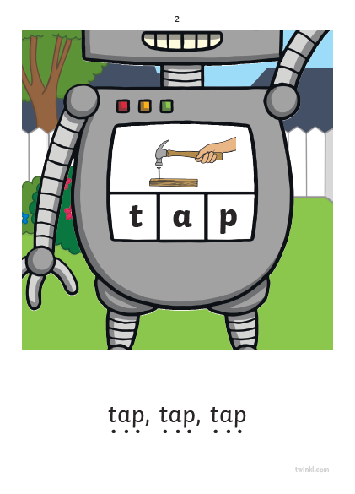

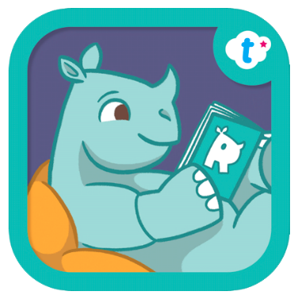

Whilst your child is learning new sounds, they will receive a Twinkl ‘minibook’ containing sounds and common exception words learnt that week. This will be given to your child as a paper copy, or it will be uploaded to Google Classroom.

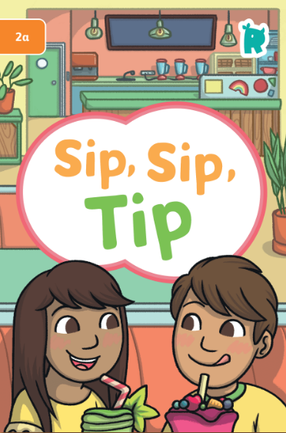
Once they have learnt a full set of sounds, your child will then receive a Rhino Reader book. Make sure your child recaps the sounds at the front of this book before reading.

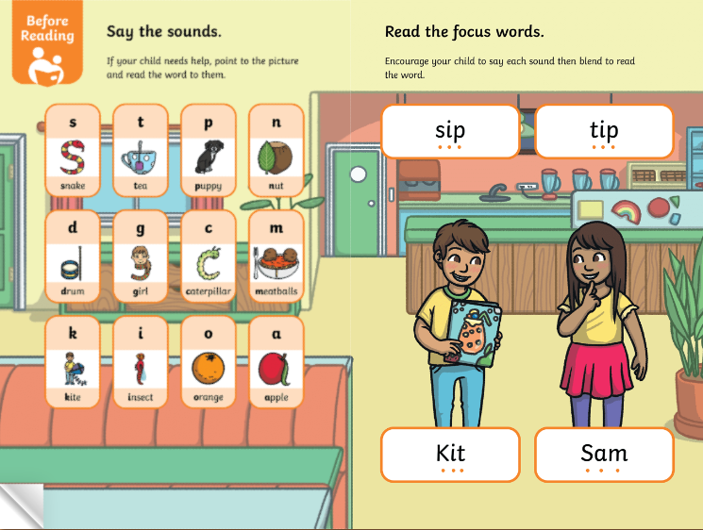

It is important to ask your child the ‘after reading’ comprehension questions, at the back of the Rhino Reader books, each time they read. As they have this book for a week, please ask them a selection of questions each day.

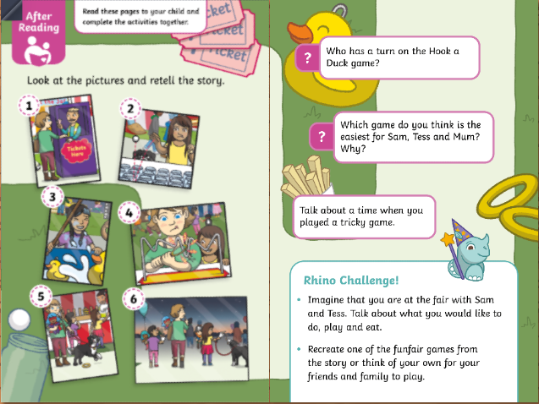
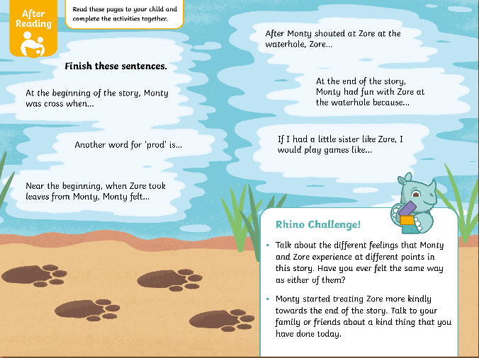

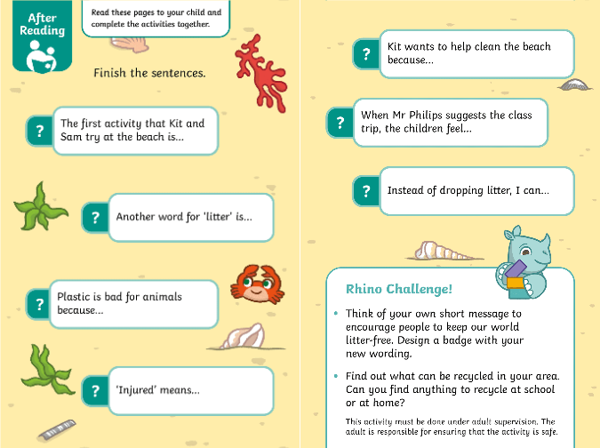

I Spy  Play ‘I Spy’ games. Can you find words beginning with...? Can you find a picture of a...? How many ... can you see? | Make it Fun  Enjoy reading together. Give characters funny voices and engage with the pictures. Make a game out of finding words that rhyme or start with the same sound. | Create  Use reading to inspire drawings or new stories.
Be Seen  Make sure you are seen reading. Keep books and magazines at easy reach. | Get Out  Go to your public library regularly. Find the books you loved as a kid to read together. | Go Online  Look online and in app stores for appropriate word and spelling games.
Make Space  Have a special place or a certain time when you read together. | Read everything out loud.  Books, poems, nursery rhymes, newspaper & magazine articles, food labels... anything that is close to hand!


