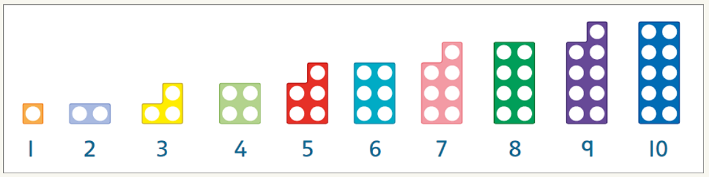
Numicon

What is Numicon?
Numicon is a fun, hands-on way to introduce your child to numbers. Each coloured shape represents a number from 1–10 and each number has its own colour. These shapes have holes arranged in pairs to help children understand number properties and spot the connections between different numbers.
Numicon brings numbers to life and allows them to see and feel the value of different numbers.
Different ways to make numbers  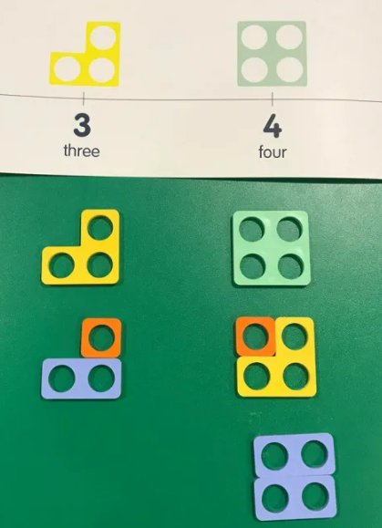 | Odd and even numbers  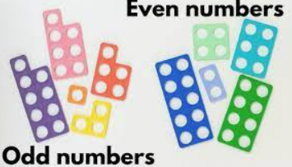  (The warm colours are odd and the even are cool colours). | Number bonds to 10  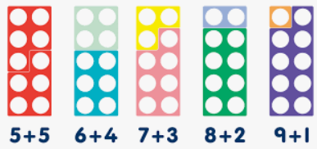
Creating and exploring  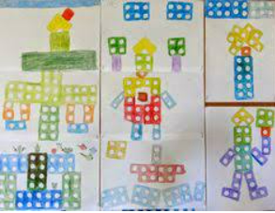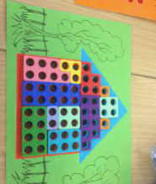 |  | Matching  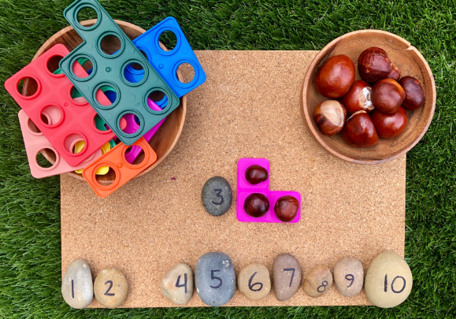

When you click the following link: https://home.oxfordowl.co.uk/maths/numicon-guide-for-parents/ the website will show you more engaging, practical ways to use the Numicon to support your child with maths.

