
Reception – recommended reading list
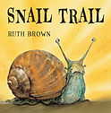 | Follow the journey of the snail as he goes over hills, through tunnels, past slippery things and finally out into a delightful surprise at the end.
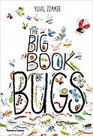 | Each double-page spread dives into a different bug-themed question, such as 'How does a butterfly flutter by?' or 'Where does the name praying mantis come from?'.
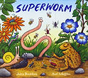 | This fast-paced story by the well-loved children's author Julia Donaldson follows the story of the unlikely hero Superworm as he is put under a spell by the Wizard Lizard.
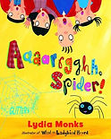 | Little Spider has a lot to prove when she wants to be the family pet. Can she convince a family who is scared of spiders to keep her?
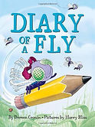 | This laugh-out-loud story offers an insight into the everyday ups and downs of being a fly.
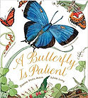 | This beautifully illustrated non-fiction text showcases butterflies, using the stunning pictures as a gentle but informative way in to explaining the science behind their life cycles.
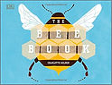 | Learn all about bees with this brightly coloured and highly appealing non-fiction picture book. Topics include where honey comes from, how hives work, why we need pollination and how to help save more bees.
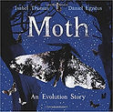 | This is a striking picture book that uses the story of a moth to demonstrate how animals can adapt and evolve over time.
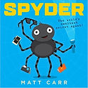 | This entertaining story follows Spyder, a secret agent arachnid whose codename is 008. Spyder is sent on a highly important mission to save one boy’s birthday cake from the destructive intentions of an uninvited Bluebottle. The story is full of puns, cool gadgets and extra information like a spider webpage at the end.
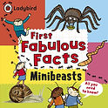 | This will introduce young children to the conventions of information texts, such as contents, headings and captions, in a fun and easily accessible way.
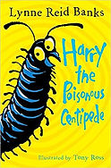 | This is an early chapter book that tells the story of a little centipede who tries to navigate the world of "hoo-mins".
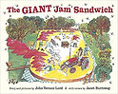 | How would you solve the problem if 1 million wasps invaded your town? The residents of Itching Down find a creative solution by trying to construct a giant jam sandwich to trap the wasps.
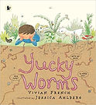 | Worms might seem yucky at first, but there's more to these wiggly fellows than meets the eye! Presented in a style to be interesting and accessible to young children, this is a lovely non-fiction text to support the minibeasts topic.
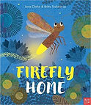 | Florence Firefly is lost and despite her ability to light up the night in the most beautiful of ways, she needs help to find her way home. This is an interactive story where readers are encouraged to join in different actions to help Florence on her journey past different bright lights to her house, including clapping and tracing patterns on the pages.
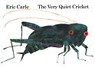 | A lesser-known story from the author of The Very Hungry Caterpillar. This is the tale of a cricket who rubs his wings together to find that he has lost his song.
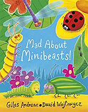 | A brightly-illustrated collection of uplifting rhymes about all sorts of minibeasts. These rhymes are ideal for reading aloud and learning by heart!
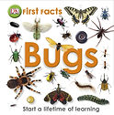 | A simple information text bursting with clear photographs and fun facts about minibeasts.
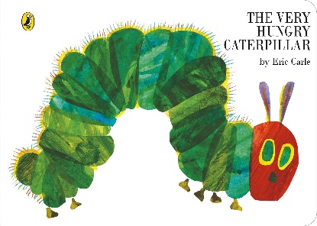 | This short story by Eric Carle is filled with topics of self-control, well-being and happiness, and growth and change.
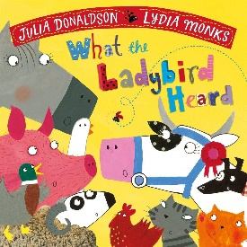 | The unsuspected and quietest animal of all saves the day!

