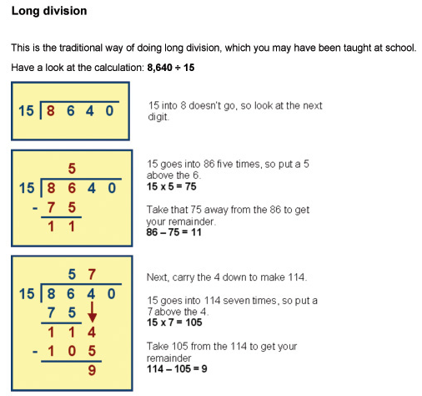
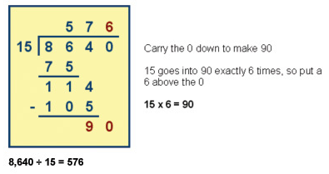
https://www.khanacademy.org/math/arithmetic/arith-review-multiply-divide/arith-review-multi-digit-div/v/long-division-without-remainder
https://www.khanacademy.org/math/arithmetic/arith-review-multiply-divide/arith-review-remainders/v/division-3-more-long-division-and-remainder-examples
https://www.mathsisfun.com/long_division.html

