LANGSHOTT PRIMARY SCHOOL
Smallfield Road, Horley
Surrey, RH6 9AU
Telephone: 01293 776341
Facsimile: 01293 821540
Email; info@langshott.surrey.sch.uk
www.langshott-surrey.co.uk
Headteacher Mrs SL Mackintosh BEd(hons) NPQH

22 May 2018

To All Parents / Carers,
As I have made you aware in recent newsletters, The General Data Protection Regulation (GDPR) is a piece of EU-wide legislation which determines how people’s personal data is processed and kept safe and the legal rights individuals have in relation to their own data. It applies from 25 May 2018 to all organisations that process or handle personal data, including schools. It is similar to the Data Protection Act (DPA) 1998; most of the differences involve the GDPR building on or strengthening the principles of the DPA.
Please find attached our new Data Protection Policy and Privacy Notice for your information, plus a consent form for photographic images. Please complete the consent form and return it after half term.
Data Protection Officer - The Data Protection Officer is responsible for overseeing data protection within the school. If you have any questions in this regard, please contact her on the information below:
Mrs Nina Dunk c/o Langshott Primary School. Email - dpo@langshott.surrey.sch.uk

Yours sincerely,
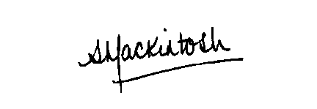
Mrs Mackintosh
Headteacher

